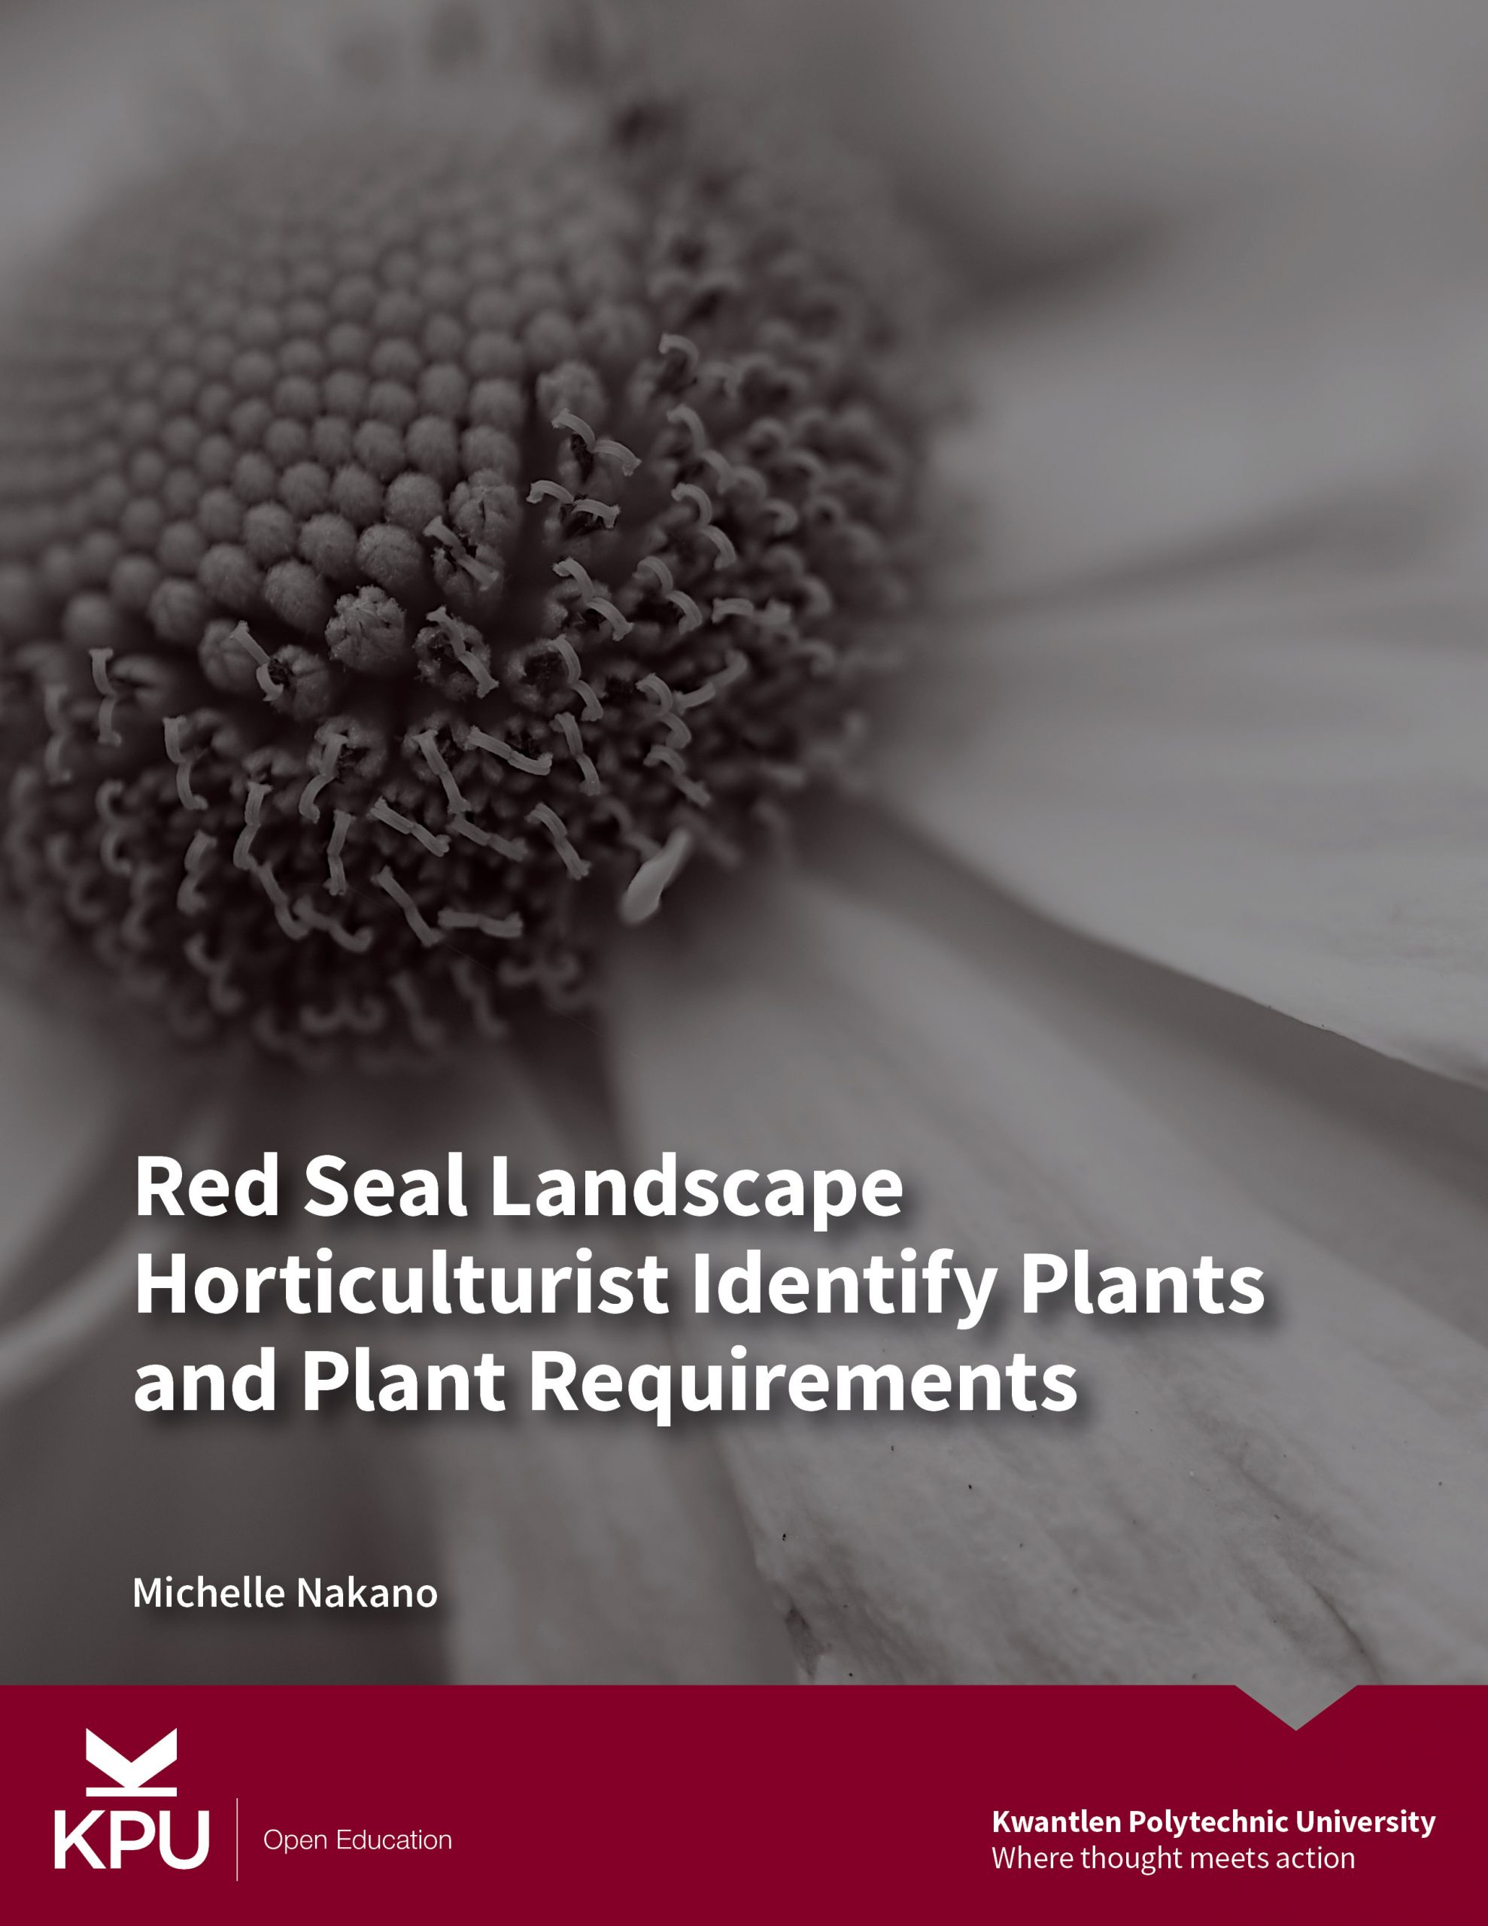

Red Seal Landscape Horticulturist Identify Plants and Plant Requirements (F2 - 1&2)

Red Seal Landscape Horticulturist Identify Plants and Plant Requirements (F2 - 1&2)

Line F Apply Horticultural Practices: F2 - Level 1 and 2
Michelle Nakano
Kwantlen Polytechnic University
Surrey, B.C

Red Seal Landscape Horticulturist Identify Plants and Plant Requirements (F2 - 1&2) by Michelle Nakano is licensed under a Creative Commons Attribution 4.0 International License, except where otherwise noted.

Contents
- Acknowledgements
- About this book
- Part 1 - Plant Identification
- Introduction to Plant Identification
- Introduction to Taxonomy
- Introduction to Taxons
- Introduction to Binomial Nomenclature
- Conventions for Binomial Nomenclature
- Nomenclature Review
- The Meaning of Plant Names
- Plant Growth
- Introduction to Plant Classification
- Classify Plants by Life Cycle
- Introduction to Dichotomous Keys
- Key to Plant Classification
- Introduction to Plant Morphology
- Plant Morphology - Leaves
- Plant Morphology - Conifers
- Plant Morphology - Flowers and Fruit
- Plant Family Characteristics
- Part 2 Plant Requirements and Use
- Plant Habitats
- Plant Use Categories
- Plant Growth Characteristics
- Characteristics of weedy species
- Plant Hardiness
- Plant Requirements

1

Acknowledgements
This textbook represents a commitment to excellence in horticulture education at Kwantlen Polytechnic University. It is a living record of Horticulture Faculty and Staff contributions to the Hort 1155 Introduction to Plant Materials Lecture Notes, 1993 – 2019. I would like to thank Aaron Roth for his dedication to the KPU Plant Database, referenced in the text. I am grateful to BCcampus for the opportunity to acknowledge my colleagues with this first open education resource for all students of plant identification.
I wish to thank Karen Meijer-Kline, KPU Library for support with the formatting and references.
Michelle J. Nakano
February, 2020

2

About this book
Red Seal Landscape Horticulturist Identify Plants and Plant Requirements is an adaptation of KPU HORT 1155 Introduction to Plant Materials Lecture Notes. It is an editable, open access learning resource with interactive web based experiences customized for horticulture students studying plant identification.
This first edition supports student achievement of the Level 1 and 2 learning goals for Red Seal Landscape Horticulturist Line F2:
- Identify plant and plant requirements for a range of plants commonly used in horticulture
- Employ correct naming and plant identification terminology
- Identify morphological characteristics, growing requirements, use and availability
- Use a dichotomous key for plant identification
- Explain plant hardiness
- Identify weedy and invasive plants

I

Part 1 - Plant Identification

1

Introduction to Plant Identification

Learning Objective
- Describe the development of plant identification.

All living organisms on Earth rely on the process of photosynthesis for food energy and oxygen. Humans depend almost entirely on plants for clean air and a livable climate as well as for food, medicines, materials, and well being. Around the world, groups of people with their own distinct history, culture, and society have learned to identify plants and their properties. For Indigenous peoples, the accumulated traditional knowledge of plants has allowed them to thrive in diverse environments for thousands of years.
Traditional knowledge passed among generations through the oral traditions of hunter-gatherers influenced the naming and grouping of plants. With the settlement of agricultural communities and the domestication of plants about 10,000 years ago, written records documented their use. Early systems of plant classification emerged in Eastern and Ancient Egyptian cultures and botany, the scientific study of plants developed in Ancient Greece.
Taxonomy, a branch of botany, is defined as the systematic classification, naming, and identification of plants. This orderly system arranges related plants with similar characteristics into groups called taxa and uses a convention called bionomial nomenclature to give a unique name to one group of plants. In addition to classification by morphology (external form) and anatomy (internal structures), botanists now use genetic sequencing and biochemistry to decode the evolutionary history of relationships among plants. As a discipline, taxonomy has continued to develop over centuries of botanical study and this knowledge is available to students of plant identification.
The ability to identify plants and their requirements has always been an essential skill for horticulturists who manage plant growth and health. However, with more than 300,000 known species in the world, the plant kingdom – Plantae, is both diverse and complex. No two species of plants will be exactly alike, and while some common characteristics may be easily seen, others are so different that few if any relationships can be observed. Furthermore, the progression of evolution never stops and relationships among plant groups continue to change over time. To address this challenge, this book introduces students of plant identification to a systematic approach to classifying, naming, and identifying unknown species.
Review

An interactive H5P element has been excluded from this version of the text. You can view it online here:
https://kpu.pressbooks.pub/plant-identification/?p=158#h5p-4

2

Introduction to Taxonomy

Learning Objectives
- Describe the scientific system of plant classification and naming.

A working knowledge of taxonomy is useful for classifying, naming, and identifying unknown plants. Theophrastus (370-285 BC), a Greek philosopher, first used taxonomy to describe and group plants according to their morphology (shape), growth, and reproductive traits. In the 18th century, a scientist named Carl Linnaeus applied binomials (two-term names) and classified known plants into a hierarchical system of classification.

Classification and Naming
The most effective classification systems are hierarchical and comprised of a nested series of categories or ranks. A good analogy is a computer filing system. Certain kinds of information reside at each level (drive, library, directory or folder, sub-directory, document, etc.), with file names (or labels) that signify the sort of information found there. Every level in the hierarchy is more inclusive than the one below it and the more of the filing system that is investigated, the more related information is uncovered.
Similarly, the categories used in plant classification provide an organizational framework into which the names of naturally occurring plants are slotted. In this framework, species of plants that are most similar to each other are grouped together. Groups or taxa (plural) are arranged in a hierarchical sequence of taxons (singular), from least inclusive rank at the bottom to most inclusive rank at the top as shown below in the plant classification hierarchy. In other words, the taxa “family” may include numerous plant genera, and within a genus (singular of genera) there may be any number of species, whereas within a given species, a subspecies may describe only a few populations or individuals.
Within taxa – family, genus, species, etc., there are identifiable characteristics common to each group. For example, plants in the cypress family typically have broad, flattened, scale leaves, while plants in the pine family exhibit needle-like leaves. Once organized into a sensible system that recognizes similarities or relatedness, the grouping becomes easier to understand and remember. That is, once characteristics for a given group are known, they can be used to match unknown plants with known taxons.

Plant Classification Hierarchy of Taxons
- Family
- Genus (plural = genera)
- Species
- Subspecies or Variety
- Forma

Other Classification terms
- Hybrid
- Cultivar
- Common Names
- Plant Groups

Review: Identify the hierarchy of plant taxons.

An interactive H5P element has been excluded from this version of the text. You can view it online here:
https://kpu.pressbooks.pub/plant-identification/?p=112#h5p-5

3

Introduction to Taxons

Learning Objectives
- Identify characteristics of taxons.

The plant family taxon is a grouping of plants consisting of one or more related genera that are more like each other than to other genera, and that includes the entire surviving lineage of the ancestral population. Family names always end with the suffix -aceae, except in a few notable cases where use of traditional names is also acceptable. Newer family names are based on the “type-genus” concept which means that for every family there is a genus that best represents the characteristics of the family. For example, Brassica(the cabbage genus) is the base for the family Brassicaceae, as is Rosa (the rose genus) for the family Rosaceae.

Older family names are still used since many are somewhat descriptive and may be more familiar than their newer counterparts. For example, Cruciferae (from the Latin crucifer, a cross) refers to the four-petal arrangement of flowers characteristic of the mustard family. The revised family names for some familiar plant groups are listed in Table 3.1.
Table 3.1: Revised family names
Traditional Name | New Name | Common Name
Compositae | Asteraceae | Aster
Cruciferae | Brassicaceae | Mustard
Graminae | Poaceae | Grass
Labiatae | Lamiaceae | Mint
Umbelliferae | Apiaceae | Carrot

Because of new discoveries and technological advancements for determining plant genetics and other markers, some genera and family names have been reclassified under new names, as shown in Table 3.2. Updates to plant information publications and online resources takes time and overlaps in established and reclassified family names can be expected.
Table 3.2: Reclassified family names
Family Name | Reclassified Name | Common Name
Aceraceae | Sapindaceae | Soapberry
Asclepiadaceae | Apocynaceae | Dogbane
Taxodiaceae | Cupressaceae | Cypress

Taxonomic Example
The list of ten Pacific Northwest native conifers can be grouped into three families. Within each family, there are a different number of genera, as represented by the common names. Within each genus, unless a monospecific (single) genus as with Taxus and Pseudotsuga, there are a number of different species.

Pinaceae – pine family
Douglas fir (Pseudotsuga, 1 species)
hemlock (Tsuga, 2 species)
larch (Larix, 3 species)
true fir (Abies, 3 species)
spruce (Picea, 4 species)
pine (Pinus, 7 species)

Cupressaceae – cypress family
arborvitae (Thuja, 1 species)
yellow cedar (Cupressus, 1 species)
juniper (Juniperus, 3 species)

Taxaceae – yew family
yew (Taxus, 1 species)

An interactive H5P element has been excluded from this version of the text. You can view it online here:
https://kpu.pressbooks.pub/plant-identification/?p=160#h5p-6

An interactive H5P element has been excluded from this version of the text. You can view it online here:
https://kpu.pressbooks.pub/plant-identification/?p=160#h5p-7

An interactive H5P element has been excluded from this version of the text. You can view it online here:
https://kpu.pressbooks.pub/plant-identification/?p=160#h5p-8

4

Introduction to Binomial Nomenclature

Learning Objectives
- Employ correct naming and plant identification terminology.

For an orderly system of classification, botanists give each group of plants a name that is recognized by people who know binomial nomenclature, regardless of where they are or the language they speak. This way every plant species will have a unique botanical name based on the binomial system of nomenclature. For example, one of the best-known trees of the Pacific Northwest, the Douglas fir, recognizes botanist Archibald Menzies in its scientific name Pseudotsuga menziesii. While the common name recognizes fellow botanist David Douglas, Archibard Menzies is credited with the first botanical description of the plant.
A plant name or binomial is made up of two names: a genus name and a (usually) descriptive specific epithet (species name), both commonly of Latin or Greek origin. For example, of the many species within the group known as pines (genus = Pinus) there is only one named Pinus contorta (contorta = twisted). This species is characterized by often having contorted or twisted young shoots. The “species name” is the binomial; for instance, the species to which we belong is Homo sapiens.

Genus
A genus (plural = genera) is defined as an assemblage consisting of one or more related species that are more like each other than to other species, and that includes the entire surviving lineage of the ancestral population. Evidence for these relationships is deduced from the fossil record and from comparative techniques in morphological, chemical and molecular (DNA sequencing) analysis.
A genus name can be descriptive of the plant, such as Equisetum (common horsetail) which is from two Latin words equus (horse) and saeta (bristle). The genus can be the actual Latin or Greek name such as Erysimum which is derived from the Greek name for the same plant erysimon. It can also be derived from the plant founder’s name such as Davidia, which is from Father David, a famous French plant explorer who lived in China for many years.

Species
The species is the basic life-unit in biology and can be defined as consisting of one or more related species that are more like each other than to other populations and that presumably come from a single ancestral population. The species name may be an adjective that indicates a distinguishing characteristic of the species, e.g., Quercus alba – white oak, or a noun that honors a person or indicates the species habitat. Species is abbreviated sp. (a single species) or spp. (more than one species).

Subspecies
Subspecies (ssp. or subsp.) and variety (var.) names are also multinomials. For example, lodgepole pine is known by the botanical name Pinus contorta var. latifolia, or sometimes, P. contorta ssp. latifolia. In other words, a northern variant of Pinus contorta with needles more flattened (lati = broad and folia = leaf) than the typical, coastal variety (P. contorta var. contorta). Note that “variety” is used here at the same rank as “subspecies” while some botanists consider the “variety” as a lower rank. These terms are used to describe naturally occurring plants.

Form
The rank form or forma (f. or fa.), is used to represent individuals which differ in some specific way from other individuals within the same natural populations. For example, one can find numerous red bract forms throughout populations of the more commonly white bract Cornus florida (Eastern flowering dogwood). These red bract dogwoods are correctly known as Cornus florida f. rubra (rubra = red). Other common, naturally-occurring mutations in other plants include: weeping habit (f. pendula), dissected leaves (f. dissecta), and white flowers (f. alba).

Hybrids
Hybrids are the offspring of successful mating between plants belonging to different taxa. Known interspecific hybrids (between species in the same genus) are designated by a multiplication sign, as Platanus × acerifolia (P. occidentalis × P. orientalis). Intergeneric hybrids result from crossing plants belonging to separate genera; an intergeneric hybrid name is always preceded by a multiplication sign, as ×Solidaster (Solidago × Aster).

Cultivars
Cultivars are horticultural races or strains of plants which originate under cultivation or may originate in nature as a mutation and subsequently persist under human cultivation. The word cultivar (cv.) comes from “cultivated variety,” a somewhat confusing derivation, since the “variety” represents a naturally occurring entity, while the cultivar does not.
As cultivars do not persist in nature, it is not a botanical designation; however, where used, the cultivar is considered part of the botanical name and must be appended to it. Cultivar names are distinguished in text using single quotation marks, as Chamaecyparis pisifera ‘Filifera Aurea’ (filaments or threads of gold).

Common Names
Common names are the local, familiar names given to plants. The same common name may be used for several completely different plants. For example, the common name “cedar” is a name given to a variety of plants with aromatic wood (recalling the “cedar” of antiquity, Cedrus spp.) or to plants that are reminiscent of other plants called “cedars,” for example. In the Pacific Northwest, cedar refers to Thuja (western red cedar) and to Cupressus (yellow cedar).
Similarly, a single species may have numerous common names, particularly if known from a variety of locations. For example, yellow cedar is also known as Nootka cypress and Alaska cedar. Clearly, there is potential for much confusion with common names. In text, common names are written out in lower case, except where they include proper names; e.g., Douglas fir, Japanese painted fern, etc. Common names are not botanical names. While botanical names are often, at least initially, difficult to remember and pronounce, they are universally recognized and considerably more accurate than common names.

5

Conventions for Binomial Nomenclature

Learning Objectives
- Describe conventions for writing botanical names.

Botanical nomenclature is the scientific system of naming plants. The naming of plants is governed by two sets of published rules: The International Code of Nomenclature for algae, fungi, and plants and the International Code of Nomenclature for Cultivated Plants. These rules establish a worldwide standard of reference for naming plants. By convention, when written in text a botanical name is always italicized or underlined, and the first letter of the genus name is always capitalized.
The following summarizes the basic rules regarding the writing of botanical names for plants:
- The generic epithet of a botanical name is always capitalized (e.g., Salvia, Impatiens), and is underlined or italicized except where it is also used as a common name, as in salvia or impatiens. Within text or in a list – but only where unambiguous – the genus name is often abbreviated to the first letter, for example, Rosa rugosa, R. moyesii, R. acicularis.
- The specific epithet of a botanical name is always lower case, and is underlined or italicized in text, as Gaultheria shallon or Gaultheria shallon. If only the genus of a plant is known, the specific epithet is abbreviated as sp. (designating a single species) or spp. (more than one species).
- Hybrids, produced from breeding 2 or more different species (interspecific), are noted by a multiplication sign between the genus and specific epithet, for example, Forsythia × intermedia.
- Hybrids produced from crosses between genera (intergeneric), are noted by a multiplication sign before the genus, for example, ×Solidaster luteus which has the following parentage, (Solidago canadensis × Aster ptarmicoides).
- Subspecies are abbreviated ssp. or subsp. The subspecies epithet is not capitalized but is underlined or italicized, for example Acer glabrum ssp. douglasii
- Variety or more officially, varietas, is abbreviated var. The variety epithet is not capitalized but is underlined or italicized, as in this example, Clematis montana var. rubens
- Form or more officially, forma, is abbreviated f. (or sometimes fa.). For example, Cornus florida f. rubra.
- Cultivars usually have vernacular names, are not italicized or underlined, and all words are capitalized and usually in single quotes. For example, Astilbe chinensis ‘Pumila’ or Ilex aquifolium ‘Ferox Argentea’.
- Group: This describes a group of unnamed tree seedlings, for example Picea pungens Glauca Group describes all the un-named seedlings with blue foliage that are available in the nursery trade. Groups names are not italicized or underlined, and all words are capitalized but are not in single quotes.
- The ™ designation indicates that the originator of the new plant, for example, Pyrus calleryana Aristocrat™, has applied for a trademarked name. The ® indicates that the plant name is a registered trademark, such as in Pyrus calleryana Chanticleer®. The trademark name is often the “selling name” of the plant, which may differ from the cultivar name. eg. Weigela florida ‘Alexandra’ is sold under the moniker Wine & Roses® weigela.

An interactive H5P element has been excluded from this version of the text. You can view it online here:
https://kpu.pressbooks.pub/plant-identification/?p=1238#h5p-47

6

Nomenclature Review

Learning Objectives
- Apply the conventions for writing botanical names.
Apply binomial nomenclature conventions to each of the plant names.

An interactive H5P element has been excluded from this version of the text. You can view it online here:
https://kpu.pressbooks.pub/plant-identification/?p=127#h5p-12

An interactive H5P element has been excluded from this version of the text. You can view it online here:
https://kpu.pressbooks.pub/plant-identification/?p=127#h5p-13

An interactive H5P element has been excluded from this version of the text. You can view it online here:
https://kpu.pressbooks.pub/plant-identification/?p=127#h5p-15

An interactive H5P element has been excluded from this version of the text. You can view it online here:
https://kpu.pressbooks.pub/plant-identification/?p=127#h5p-16

An interactive H5P element has been excluded from this version of the text. You can view it online here:
https://kpu.pressbooks.pub/plant-identification/?p=127#h5p-17

An interactive H5P element has been excluded from this version of the text. You can view it online here:
https://kpu.pressbooks.pub/plant-identification/?p=127#h5p-18

An interactive H5P element has been excluded from this version of the text. You can view it online here:
https://kpu.pressbooks.pub/plant-identification/?p=127#h5p-19

An interactive H5P element has been excluded from this version of the text. You can view it online here:
https://kpu.pressbooks.pub/plant-identification/?p=127#h5p-20

An interactive H5P element has been excluded from this version of the text. You can view it online here:
https://kpu.pressbooks.pub/plant-identification/?p=127#h5p-21

An interactive H5P element has been excluded from this version of the text. You can view it online here:
https://kpu.pressbooks.pub/plant-identification/?p=127#h5p-22

7

The Meaning of Plant Names

Learning Objectives
- Describe the meaning of botanical names.

Botanical names often provide a helpful description of a plant. The origins of Latin and Greek names may be classical, mythological, or commemorative, or they may relate to a place, area, or season. Descriptors for plant surface characteristics or color, habitat, growth habit, and size and shape are other common sources for specific epithets. Familiarity with their meaning is helpful for remembering plant names. References such as the Dictionary of Plant Names by Allen J. Coombes (1994) or The Names of Plants (1996) contain interesting information on the origin and meaning of plant names. Information is also available online at these links to Califlora: Plant Name Meanings and Derivations [New Tab] and The Meaning of Latin Plant Names [New Tab].

Practice: Identify the meaning of each of the specific epithets using the links above to online resources.

An interactive H5P element has been excluded from this version of the text. You can view it online here:
https://kpu.pressbooks.pub/plant-identification/?p=129#h5p-23

8

Plant Growth

Learning Objectives
- Identify common classifications of plant growth.

Water movement is the most basic classification of plant growth. All plants need water to survive and, based on how they move water, are categorized as either vascular or non-vascular. Vascular plants, such as trees, have a water conducting system, allowing them to supply aerial tissues with water and to grow well above the ground. Non-vascular plants rely on their closeness to water and their own physical absorption to support green tissues above ground. Mosses and liverworts are examples of non-vascular plants.
Reproduction is another classification of vascular plants that is based on whether they reproduce themselves asexually or sexually. Vascular plants are subdivided into two major categories, pteridophytes, and spermatophytes. Pteridophytes (Greek for “fern plant”) include ferns and horsetails that reproduce asexually by spores. Spermatophytes (Greek for “seed plant”) include conifers and flowering plants that reproduce sexually by seed.
Conifers, from the Latin for “cone-bearing” are woody plants that bear their female and male reproductive structures in separate cones or strobili rather than in flowers. Coniferous trees and shrubs typically bear both female and male cones on the same plant. Pollen produced by male cones is transported on wind currents to the female cones wherein seed development is completed. Conifers belong to the group of seed producing plants called gymnosperms. Gymnosperm literally means ‘naked seed’ as seeds are held on the surface of a cone scale or at the end of a small structure. This is the main differentiation between conifers and the flowering plants (angiosperms) which bear their seeds in an enclosed ovary of a flower that becomes the fruit.
Angiosperms are the largest and most diverse group in the plant kingdom. Some angiosperms produce flowers and fruit over many years (polycarpic), while some die after flowering and bearing fruit only once (monocarpic). In addition to the presence of flowers and fruit, angiosperms are classified according to two major groups of plants that are each derived from a common ancestor species (clade), the monocotyledons and eudicotyledons. This classification is based on the number of cotyledons or seed leaves produced at seed germination. Monocotyledons (meaning “single seed-leaf”) include grasses, lilies, orchids, and palms. They develop from a seed with a single seed leaf. Some basic recognizable patterns of monocotyledons include leaf veins arranged in parallel lines; flower parts numbered in 3’s and a herbaceous plant structure. Eudicotyledons (meaning “true dicots”), are an evolutionary line that includes plants such as maples, oaks, roses, buttercups, mints, and sunflowers that develop from seed usually with a pair of seed leaves. Some basic recognizable patterns of dicotyledonous plants include leaves with netted venation; flower parts numbered in 4’s or 5’s and woody or herbaceous plant structure.
Type of growth, such as tree versus shrub or woody versus non-woody (herbaceous), is often the first visual recognition of a plant. Plant growth may also be categorized by some aspect of their biology or ecology such as: terrestrial or aquatic habitat (e.g., duckweed), adaptations such as twining stems for climbing (wisteria) or underground storage bulbs (e.g., daffodil), or whether they exhibit seasonal loss of leaves (deciduous) or if they remain evergreen.
Plant growth varies from trees with well-defined trunks, to multi-stemmed shrubs and climbers to spreading ground covers and clumping herbaceous plants. The above ground plant structure is typically formed by stems that are either woody or herbaceous. Woody plants such as cedars, oaks, and maples produce more or less permanent structures capable of extension and annual thickening (secondary growth). Non-woody or herbaceous plants such as dandelion, (eudicot) and grasses (monocot), and ferns, (pteridophyte) are limited to only extension growth and do not produce permanent above ground structures.
The herbaceous growth habit is common among vascular plants, and many specific plant groups are distinguished on that basis. Herbaceous plants are characterized by a lack of woody tissue, such as bark. Their stems will eventually die back to a live root crown and root structures. Deciduous herbaceous perennials wither and die back to some kind of long-lived, resistant organ (a fleshy crown, bulb, tuber, rhizome, etc.) and enter a state of dormancy when conditions are not suitable for continued growth. In comparison, evergreen herbaceous plants have leaves that persist over one or more seasons of growth.
Not all herbaceous plants are seed plants; spore producing plants such as ferns and horsetails are also considered herbaceous. The ability of some perennial plants to propagate themselves non-sexually by means of vegetative reproductive structures such as underground creeping stems (rhizomes) and tubers and bulbs is a competitive advantage over sexually reproduced plants and provides an effective adaptation for spreading.
Plants with a climbing growth habit may be woody or herbaceous. Vines (herbaceous) and lianas (woody) have various specialized adaptations for climbing on, through, and over host plants and surrounding objects to gain access to light. Self-clinging climbers attach themselves to supports by aerial (adventitious) roots or by modified leaf structures called tendrils. Tendril climbers twine around or adhere themselves to supports by contact sensitive tendrils with adhesive discs at the tips. Climbers with twining stems or curling leaf stalks coil around supports in a clockwise or counterclockwise spiral habit. Scrambling (scandent) or trailing climbers with long arching stems attach loosely, if at all to supports. Some species, such as roses, are equipped with stem modifications of hooked thorns that allow them to scramble through other plants.

An interactive H5P element has been excluded from this version of the text. You can view it online here:
https://kpu.pressbooks.pub/plant-identification/?p=117#h5p-31

9

Introduction to Plant Classification

Learning Objectives
- Recognize and describe patterns used to classify plants.

Classifying unknown plants as identical with or similar to plants within a particular taxonomic group involves observation and comparison. The ability to accurately distinguish and categorize the similarities and subtle differences among plant species relies on at least three interrelated skills: pattern recognition, description, and classification.
Pattern recognitionincludes awareness of visual indicators such as shape, size, habit, etc. as well as other sensory input such as smell, touch, sound, etc. Much pattern recognition depends upon our ability to describe what is perceived. Frequently, people don’t remember those things they can’t describe in words. In contrast, those things, which are related to other more familiar things, are more easily recalled: for example, “it feels like velvet,” “it smells of lemons,” or “it appears to be bigger than a breadbox”.
Descriptionsallow people to identify and catalog those patterns. “Striped,” “spotted,” “rough” and “smooth” are simple descriptors. It is not difficult to remember such patterns. Other, more complex descriptors are needed for characterizing complex organisms. The “trick” is in recognizing the patterns that indicate important relationships. There is a significant amount of vocabulary involved in describing plants, and the student of plant identification must learn to apply both plant morphology (the study of shape) and the descriptive terminology.
Classification is an effective method for organizing data. People naturally classify things according to various categories. Based on their usefulness, some plants may be considered more desirable than others. For example, plants considered to be undesirable for health or economic reasons are often categorized as weeds. Additional categories used for plant classification include their utility (medicinal plants), cultural tolerances (house plants), growth form (trees), leaf shape (needle vs. broad leaves), their assumed evolutionary relationships and genetic sequences (phylogenetics), among others.

An interactive H5P element has been excluded from this version of the text. You can view it online here:
https://kpu.pressbooks.pub/plant-identification/?p=162#h5p-9

10

Classify Plants by Life Cycle

Learning Objectives
- Describe characteristics of plant life cycle classifications.

A plant will go through a sequence of stages from seed germination to seed production as a mature plant. For some plants, this sequence, or life cycle may take a few weeks while others continue to grow and flower repeatedly over many years. Plant life cycles are classified as annual, biennial, or perennial. Annuals complete their life cycle of germination from seed, growing, flowering, fruiting and dying within a single season of growth. Biennials require two seasons to complete their life cycle. In the first season, foliage production and storage of food reserves takes place followed by flowering, seed production and death in the next. Perennials typically flower annually once established and may live for several to a great number of years.

Types of Annuals
While the annual life cycle is completed within a single season of growth, the term annual or bedding plant may also be used to describe any plant that is grown outdoors in the spring and summer for one growing season.
Annual flowers differ in their tolerance to cold weather and frost. Hardy annuals are the most cold tolerant; they will take light frost and some freezing weather without being killed. In most cases, hardy annuals can be planted in the fall or in the spring before the last frost date. Examples of hardy annuals include Lathyrus (sweet pea), Viola (pansy), and Tagetes (marigold) cultivars. Most hardy annuals are not heat tolerant and usually decline and die with the onset of hot summer temperatures. Another type of hardy annual is the winter annual that germinates in the fall, overwinters as a rosette of leaves, and flowers in late winter and early spring. Species of Stellaria (chickweed) and Cardamine (snapweed) are examples of winter annuals.
Half-hardy annuals will tolerate periods of cold damp weather, but will be damaged by frost. Most half-hardy annuals can be seeded outdoors in early spring since they do not require warm soil temperatures to germinate. Seeds or plants are normally planted after the last spring frost. Examples of plants grown as half-hardy annuals are Cosmos (cosmos) and Tropaeolum (nasturtium). Some half-hardy annuals may decline in the midsummer heat but may re-bloom in late summer or fall.
Because most tender annuals are native to warm tropical regions of the world, they are sensitive to cold soil temperatures and are easily damaged by frost. Most seeds will not survive freezing soils temperatures and will not germinate when soil temperatures are below 15°C. It is recommended to wait two to three weeks after the last spring frost to sow seeds or transplant outdoors. Tender annuals include species of Begonia (begonia)and Impatiens (impatiens).
While some plants may be perennial in tropical regions, they are categorized as cool- or warm-season annuals when planted in colder regions. Cool-season annuals, such as Pelargonium (geranium), Petunia (petunia), and Antirrhinum (snapdragon), grow best when temperatures are in between 20° and 25° C. during the day. Best flower production is in the spring and fall; flower production tends to decline in the middle of a hot summer. Warm-season annuals, such as Zinnia (zinnia) perform well when day time temperatures are between 26° and 32°C. and night time temperatures are between 15° and 20°C.

Biennials
The life cycle of biennial plants is completed over two growing seasons. During the first season, they produce only leaves—usually in a rosette. Following a winter cold period, they flower in the second growing season, produce seeds, and then die. Popular biennials include Digitalis (foxglove) and Oenothera (evening primrose). Cultural practices are basically the same as for annuals, except that the plants are alive for two growing seasons.
Biennials present the obvious disadvantage of producing only foliage the first year. One solution is to sow biennial seeds in mid-summer so that the plants will develop during the summer and fall. After exposure to the winter cold, they will develop flowers in the spring.

Perennials
Perennial plants can be either short-lived or long-lived herbaceous or woody plants. Short-lived herbaceous plants such as Gaillardia (blanket flower) may live for only a few years, or they can be long-lived like Paeonia (peony). Woody plants also classify as perennials, though they are rarely referred to as such. Woody species have stems that continue to grow, developing a permanent structure that the plant cannot ‘replace’ once removed. Some woody plants live tremendously long lives, such as the 9500 year old Picea sp. (spruce) in Sweden and British Columbia’s 1000 year old Thuja plicata (western red cedar). Perennials that flower and fruit only once and then die are termed monocarpic. However, most perennials are polycarpic, flowering over many seasons in their lifespan.

Common hardy herbaceous plant families include:
Asteraceae – sunflowers
Brassicaceae – mustards
Crassulaceae – sedums
Liliaceae – lilies
Lamiaceae – mints
Poaceae – grasses
Ranunculaceae – buttercups

An interactive H5P element has been excluded from this version of the text. You can view it online here:
https://kpu.pressbooks.pub/plant-identification/?p=225#h5p-11

11

Introduction to Dichotomous Keys

Learning Objectives
- Describe the characteristics of dichotomous keys.

A dichotomous key is a useful tool for the identification of things not known to the observer; for example, unfamiliar plant species. The typical dichotomous key, as shown in the example below, is made up of a series of descriptions, features or characteristics, arranged in pairs (couplets) of contrasting alternative choices (e.g., hairy vs. not hairy, bigger than a breadbox vs. not bigger than a breadbox, etc.). Each couplet is worked through sequentially until the correct determination is made.
Starting at the first couplet, choose which of the two alternatives best suits an object or thing, and proceed to the couplet number or answer indicated by that choice. The number of things being considered is reduced at each successive step in the key so that by a process of elimination the correct determination is made.

Example Dichotomous Key
Example objects to identify: apple tree, water-lily, fir tree, dandelion, astroturf, seaweed.
- 1.a. found in water …………………………………………………………………………………….. go to 2
- 1.b. found on land ……………………………………………………………………………………… go to 3
- 2.a. grows in salt water ……………………………………………………………………………… seaweed
- 2.b. does not grow in salt water ………………………………………………………………… water-lily
- 3.a. a real plant ………………………………………………………………………………………….. go to 4
- 3.b. not a real plant ……………………………………………………………………………………. astroturf
- 4.a. grows more than 50 m tall …………………………………………………………………… fir tree
- 4.b. grows less than 50 m tall …………………………………………………………………….. go to 5
- 5.a. produces yellow flowers ……………………………………………………………………. dandelion
- 5.b. does not produce yellow flowers ……………………………………………………… apple tree
Or, the couplets may be grouped like this:
- 1.a. found in water …………………………………………………………………………………… 2
- 2.a. grows in salt water …………………………………………………………………………….. seaweed
- 2.b. does not grow in salt water ……………………………………………………………….. water-lily
- 1.b. found on land …………………………………………………………………………………….. 3
- 3.a. real plant …………………………………………………………………………………………… 4
- 4.a. grows more than 50 m tall …………………………………………………………………. fir tree
- 4.b. grows less than 50 m tall …………………………………………………………………… 5
- 5.a. produces yellow flowers ……………………………………………………………………. dandelion
- 5.b. does not produce yellow flowers ………………………………………………………. apple tree
- 3.b. not a real plant …………………………………………………………………………………… astroturf

Dichotomous keys may be simple or complex depending on what is being identified. For example, distinguishing obvious visible characteristics, such as structures for water movement in woody or herbaceous plant growth is straightforward. However, it should be noted that leaves, flowers, and fruit will not typically be available at the same time and return visits may be needed. Furthermore, differentiating minute plant parts such as reproductive structures requires the use of a hand lens or low magnification microscope for inspection and a thorough understanding of the descriptive terminology used in a dichotomous key.
An example of a dichotomous key for plant identification is available online at this link to Oregon State University Dichotomous Key [New Tab].

12

Key to Plant Classification

Learning Objectives
- Use a dichotomous key for plant classification.

Dichotomous keys help improve pattern recognition and understanding of the descriptive terminology used to classify important distinctions among plants. The following dichotomous key can be used outdoors to classify a range of plants by type, growth habit, and reproductive method.

Use a dichotomous key for plant classification

Key to Plant Classification
- 1.a. Plants rely on their closeness to water and absorptive green tissues above ground………………………………………………………………………….. Non-vascular plant (go to 2)
- 1.b. Plants have a water conducting system that supplies above ground tissues with water and allows growth above ground ………………………………. Vascular plant (go to 2)
- 2.a. Plants, (conifers and flowering) that reproduce by seed …………………………………………………………………………………………… Spermatophyte (go to 3)
- 2.b. Plants that reproduce by spores …………………………………….. Pteridophyte (go to 4)
- 3.a. Spermatophyte that flowers and develops seeds within ovaries that mature into fruits ……………………………………………………………………………………….. Angiosperm (go to 4)
- 3.b. Spermatophyte that flowers and develops seeds ‘naked’ in cones (conifer) ……………………………………………………………………………………………… Gymnosperm (go to 5)
- 4.a. Plants with primary growth tissue only, lacking woody tissue like bark ………………………………………………………………………………………………… Herbaceous (go to 6)
- 4.b. Plants with secondary growth tissue, like bark ………………………… Woody (go to 5)
- 5.a. Woody plants with one or few main stems …………………………………… Tree (go to 7)
- 5.b. Woody plants with multiple stems emerging from base …………….. Shrub (go to 7)
- 6.a. Non-woody tissue does not persist over one or more seasons; withers and dies back to fleshy crown, bulb, tuber, or rhizome ……………………………………………………………………………….. Deciduous herbaceous (go to 8)
- 6.b. Non-woody tissue and leaves persist over one or more seasons of growth ……………………………………………………………………………….. Evergreen herbaceous (go to 8)
- 7.a. Trees or shrubs that lose their leaves every autumn…………… Deciduous (go to 8)
- 7.b. Trees or shrubs that are never entirely leafless …………………………………………………………………….. Evergreen or semi-evergreen (go to 8)
- 8.a. Herbaceous angiosperm that produces a single seed leaf; leaves have parallel venation; flower parts are in 3’s ……………………………………………………. Monocotyledon
- 8.b. Woody or herbaceous angiosperm that produces a pair of seed leaves; leaves have netted venation; flower parts are in 4’s or 5’s …………………………. Eudicotyledon

13

Introduction to Plant Morphology

Learning Objectives
- Describe the morphological characteristics of herbaceous and woody stems.

Plant identification relies on knowledge of taxonomy and understanding of stem, leaf, bud, flower and fruit morphology. Morphology is the Greek word for “the study of shape,” and plant morphology is the study of the external plant structures and shapes. While the original botanical resource, Species plantarum was published by Carolus Linnaeus in 1753, one of the most comprehensive references currently available for plant morphology is Huxley, A. (ed.) The New Royal Horticultural Society Dictionary of Gardening. London, Macmillan Press, 1992.
A working knowledge of morphological descriptors for plant identification enables the use of dichotomous keys as well as herbarium samples and digital databases. A herbarium is a collection of pressed and dried plants that is systematically arranged for research and plant identification purposes. Media 13.1: Plant Collecting & Herbarium Research Pt 1 [New Tab] shows the procedure for collecting and preparing plants for herbarium samples.

One or more interactive elements has been excluded from this version of the text. You can view them online here: https://kpu.pressbooks.pub/plant-identification/?p=131#oembed-1
Media 13.1: Plant Collecting & Herbarium Research Pt 1 can be found online at https://youtu.be/Y4OzLI1qYh8
Information about an institutional herbaria is available at this link to the University of British Columbia Beaty Biodiversity Museum [New Tab].
Digital databases and apps typically use the morphology of stems, leaves, flowers, and fruit to identify unknown plants . Examples of regional databases are available at these links to the Kwantlen Polytechnic University Plant Database [New Tab], Oregon State University Landscape Plants [New Tab], and University of British Columbia E-Flora BC [New Tab].

Stem Morphology
A morphological description usually starts with the structure of a plant. Plant stems with vascular tissue support leaves and reproductive structures such as flowers. Depending on the type of plant, stems may be woody or herbaceous, and solid or hollow in cross section.
Herbaceous (non-woody) stems with solid or hollow stems are typical of forbs (eudicots), grasses, and grass-like plants called rushes and sedges (monocots). The stems are generally filled with a soft spongy tissue called pith, that stores and transports nutrients. The culm (stem) of a grass plant (Poa spp.) is hollow with pith only at the jointed nodes. The base of the leaf circles around the stem forming a series of overlapping sheaths. Sedges (Carex spp.), differ from grasses and rushes in that the stems are triangular (V-shaped) in cross section at the base (“sedges have edges”), have a solid pith, and are not jointed. Rushes differ from grasses in that stems are not jointed (no nodes) and are typically filled with pith. Some rush genera, such as Luzula spp. can look very grass-like with leaf blades while in Juncus spp. the leaves may be reduced to just a rounded sheath. Examples of these morphological characteristics are available at this link to Grasses, Sedges and Rushes [New Tab].
In contrast to herbaceous stems that die at the end of the growing season, woody stems are permanent structures that grow in length and girth (diameter) each year and produce bark as a protective covering. The general features of the woody stem illustrated in Figure 13.1 will be characteristic for a particular plant species.

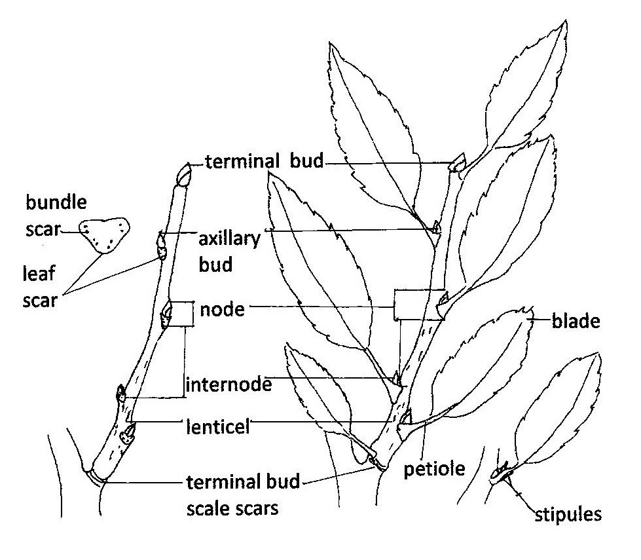

The shape, size and arrangement of buds and lenticels (small openings in the outer bark that allow for the exchange of gases), are often identifiable in trees and shrubs, as shown in Figure 13.2 and Figure 13.3. The thickness, texture, pattern, and color of the bark of many woody plants is both a distinctive species characteristic for identification and an attractive feature for landscape use.

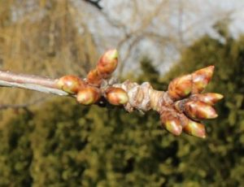

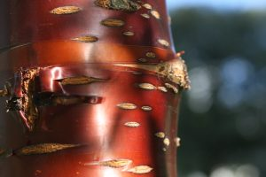

Examples of the morphology of herbaceous stems and woody stems and buds are available at this link to Stems – External KPU.ca/Hort [PDF] [New Tab].
Stem modifications include underground, above ground, and aerial structures that are characteristic to different plant species. Underground structures for spreading and food storage include rhizomes, corms, tubers, and bulbs. Stolons, runners, suckers, and offsets that grow almost parallel to or just above the ground enable plant spread. Aerial modifications include stem tendrils and thorns for climbing and protection. In xeric (dry) conditions, the stem may take over photosynthesis in order to reduce water loss from leaves (Cactus spp.). Examples of different types of stem modifications are shown at this link to Modifications – Stem KPU.ca/Hort [PDF] [New Tab].

True or False: Search the botanical names for plant information available at this link to the KPU Plant Database [New Tab]

An interactive H5P element has been excluded from this version of the text. You can view it online here:
https://kpu.pressbooks.pub/plant-identification/?p=131#h5p-32

An interactive H5P element has been excluded from this version of the text. You can view it online here:
https://kpu.pressbooks.pub/plant-identification/?p=131#h5p-33

An interactive H5P element has been excluded from this version of the text. You can view it online here:
https://kpu.pressbooks.pub/plant-identification/?p=131#h5p-34

An interactive H5P element has been excluded from this version of the text. You can view it online here:
https://kpu.pressbooks.pub/plant-identification/?p=131#h5p-37

An interactive H5P element has been excluded from this version of the text. You can view it online here:
https://kpu.pressbooks.pub/plant-identification/?p=131#h5p-38

14

Plant Morphology - Leaves

Learning Objectives
- Describe the morphological characteristics of plant leaves.

Leaves are specialized structures for photosynthesis that provide plants with energy. Leaves arise at nodes just below an axillary bud on woody stems and are usually petiolate, that is composed of a blade and stalk-like petiole. Petioles may have stipules, two small leaf-like flaps that are attached at the base. In some cases, stipules on leaves and stems may become modified into spines, thorns, or prickles. Some leaves are sessile, that is, they lack petioles and have blades directly attached to the stem. When a bud is located in the axil of a single leaf and the stem, as shown in Figure 14.1 the leaf is classified as simple.

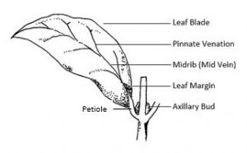

However, when a bud is located in the axil of a structure with more than one leaf (leaflet) on attached to the axis (rachis), the leaf is classified as compound. As shown in Figure 14.2, even or odd numbers of leaflets may be pinnately compound that is, arranged along a central axis (feather-like), or palmately compound from one point on the tip of the petiole, (like fingers on an out-stretched hand). Compound leaves may undergo double (bipinnate) or triple (tripinnate) compounding into finer segments or leaflets.

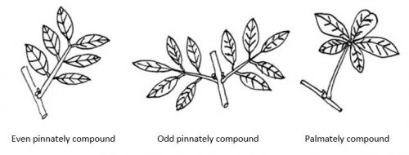

Phyllotaxy, the arrangement of a leaf or bud in relation to another leaf or bud along a plant stem is a useful basis for classifying plants. Figure 14.3 illustrates common leaf arrangements where leaves and buds on a stem are opposite (directly across from each other on the stem), alternate (spaced alternately along the stem axis), whorled (three or more leaves and buds are positioned at a node), or basal (emerging from the base). Leaf arrangement may also be described as spiral, clustered, decussate (alternating pairs at right angles), and imbricate (overlapping scales).

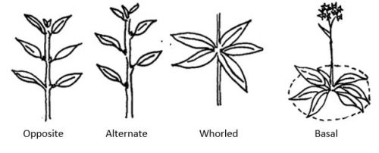

Leaf venation refers to the patterns of veins within the leaf blade. In eudicot plants, leaf venation is typically either pinnate or palmate and may have multiple branching that gives an overall netted appearance. In contrast, monocots will have parallel leaf venation. Additional morphological features for description include leaf shape, tip and base features, and margins (edges). Leaf surface characteristics vary and some may be smooth (glabrous) or with hairs (hirsute or pubescent), wrinkles (rugose), pustules (verrucose) or other interruptions of the surface. Additional leaf surface terms are defined at this link to Leaf [New Tab].
Figure 14.4 and Figure 14.5 illustrate components of a leaf morphology chart commonly used for plant identification. More detailed information about the external characteristics of leaves is available at this link to Leaf Morphology [New Tab].

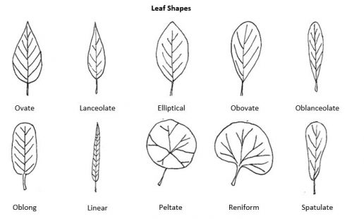

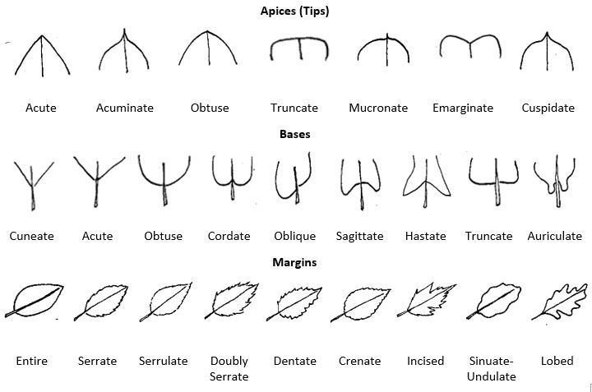

Use morphological descriptors for leaf parts. Click the image hot spots.

An interactive H5P element has been excluded from this version of the text. You can view it online here:
https://kpu.pressbooks.pub/plant-identification/?p=295#h5p-40

An interactive H5P element has been excluded from this version of the text. You can view it online here:
https://kpu.pressbooks.pub/plant-identification/?p=295#h5p-41

15

Plant Morphology - Conifers

Learning Objectives
- Use a dichotomous key to identify conifers.

Both evergreen and deciduous leaves exhibit characteristic broad blades in angiosperms, and narrow needle, scale-like, or awl-shaped leaves in the conifers. Figure 15.1 illustrates the different types of conifer leaves. Leaves may be borne singly on the shoot as in Picea spp. (spruce), in tufts or clusters as in Larix spp. (larch), or in fascicles (bundles) of 2-5 as in Pinus spp. (pines). The awl-shape and scale-like foliage of Juniperus spp. exhibits leaf dimorphism where a juvenile leaf form differs from the mature leaves of the same plant.

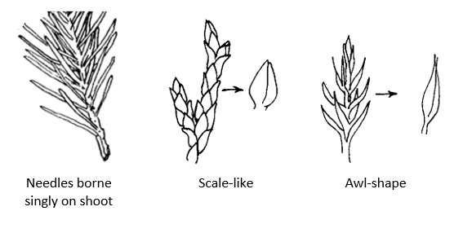

Dichotomous Key for Some Common Conifers. Click the links for plant images.

  - 1.a. leaves long, needle-like ……………………………………………………………………. go to 2
  - 1.b. leaves lanceolate, awl or scale-like, overlapping, not needle-like ……………………………………………………………………………………………………………….. go to 5
  - 2.a. needles in bundles or tufts ………………………………………………………………. go to 3
  - 2.b. needles borne singly ……………………………………………………………………….. go to 7
  - 3.a. needles in bundles of 2 to 5 …………………………………………………………….. go to 4
  - 3.b. needles deciduous, many in a tuft …………………………. Larixdecidua [New Tab]
  - 4.a. 5 needles per bundle ……………………………………………… Pinusstrobus [New Tab]
  - 4.b. 2 needles per bundle …………………………………………………………………….. go to 10
  - 5.a. scales imbricate (overlapping) cones small, upright………………… Thujaplicata [New Tab]
  - 5.b. scales imbricate, cones spherical or oval, opening along sutures at maturity ……………………………………………………………………………………………………………….. go to 6
  - 6.a. cones small, spherical; cone scales with a prominent point …………………………………………………………………… Cupressusnootkatensis [New Tab]
  - 6.b. cones larger, oval, cone scales thick, deeply pitted …………………………………………………………….. Sequoiadendrongiganteum [New Tab]
  - 7.a. needles stiff and sharp, 4-sided ………………………………………………………. go to 8
  - 7.b. needles flat and pliable …………………………………………………………………… go to 9
  - 8.a. needles extremely sharp, new growth coated with bluish wax……………………………………………………. Piceapungens Glauca Group [New Tab]
  - 8.b. needles not extremely sharp, not coated with bluish wax …………………………………………………………………………………….. Piceaabies [New Tab]
  - 9.a. needles dull green, 2 cm long, borne on short pegs that persist after the needles fall ………………………………………………………..Tsuga heterophylla [New Tab]
  - 9.b. needles shining green, 2 cm long, not borne on pegs …………………………………………………………………….. Pseudotsugamenziesii [New Tab]
  - 10.a. needles < 7 cm long …………………………………………………………………….. go to 11
  - 10.b. needles > 7 cm long …………………………………………… Pinusnigra [New Tab]
  - 11.a. needles dark green, 3-6 cm long, cone scales with a small recurved prickle ………………………………………………………………………………. Pinus contorta [New Tab]
  - 11.b. needles bluish green 5-7 cm long, slightly twisted, cone scales without a prickle ………………………………………………………………….. Pinus sylvestris [New Tab]

16

Plant Morphology - Flowers and Fruit

Learning Objectives
- Describe the morphological characteristics of flowers and fruit.

The most significant patterns, in terms of evolutionary relationships, involve reproductive structures, such as the number and arrangement of flower parts, or the structure of cones. While the size and shape of vegetative structures such as leaves and stems are relatively plastic or changeable, the basic patterns of reproductive structures change little over time. Although access to flowers and fruit may be seasonal, digital resources and herbarium samples allow the identification of patterns and relationships within plant taxa.

Flower and Inflorescence Morphology
Flower shape, color, and markings are all valuable features for plant identification. Figure 16.1 illustrates some flower shapes that are commonly used for identification purposes.

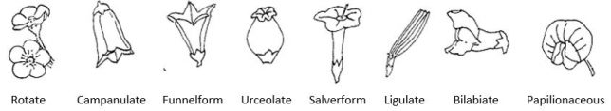

A typical angiosperm flower is borne on a peduncle (stalk) and is composed of the receptacle, sepals (calyx), petals (corolla), stamens, and pistil (carpel). Flower parts may be fused or separate and usually exhibit radial (star-shaped) symmetry or bilateral (two-mirror image halves) symmetry as shown in Figure 16.2.

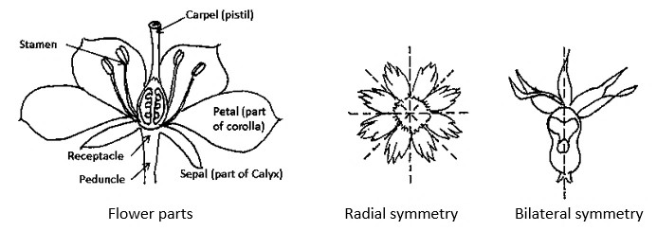

In addition to their shape, flowers are often differentiated by further dissections of their structure. For example, complete flowers must have all four main flower parts: sepals, petals, stamens (male) and pistils (female), while incomplete flowers will be missing one or more of these parts. Most flowering plants have perfect flowers that contain both male and female reproductive parts. However, some have imperfect flowers that contain only the male or female part (stamen or pistil) and may or may not contain sepals or petals. A species may have individual plants that are dioecious, producing either male or female flowers or cones on separate plants. Plants that are monoecious produce both female and male flowers and cones on one plant. Flower parts and structures can be examined at this link to Flower Morphology KPU.ca/Hort [PDF] [New Tab].
Angiosperms produce flowers which are arranged on a structure called an inflorescence. An inflorescence may support a solitary flower or display individual flowers (florets) to pollinators or expose flower parts to pollen carried on air currents. Figure 16.3 illustrates types of inflorescence commonly found in both woody and herbaceous plants.

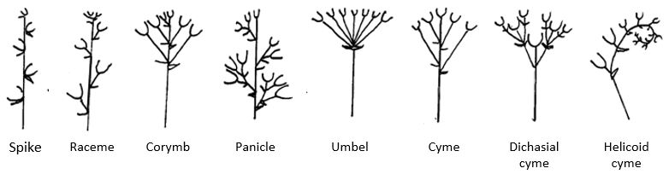

Representative characteristics of flowers and inflorescence can be examined at this link to Inflorescence Types KPU.ca/hort [PDF] [New Tab].

Fruit Morphology
For the majority of angiosperms, when a flower is pollinated, the pollen joins with an egg to produce a seed. The seed develops within the ovary which is part of the pistil, a female reproductive organ of the flower. The expanded and ripened ovary is referred to as the fruit. Commonly, the enlarged ovary becomes the edible portion of the fruit.
Fruits are classified into one of three main groups: simple, aggregate, or multiple, as shown in Figure 16.4 and Figure 16.5. Simple fruits, which form from a single, ripened ovary, may be either fleshy or dry. Fleshy fruits include the berry (grape), pepo (pumpkin), hesperidium (orange), drupe (plum), and pome (apple). Aggregate fruit develop from a single flower with numerous pistils. Once fertilized, the individual pistils develop into tiny fruitlets clustered on a single receptacle, as in a raspberry or blackberry. Multiple fruits, such as pineapples, form when numerous fertilized flowers in a single inflorescence develop together into a larger fruit.
Dry fruits, are either dehiscent (split open at maturity) or indehiscent (remain closed at maturity). Dry fruits that split at maturity include the legume (pea), silique (mustard), follicle (milkweed), and capsule (cotton). Dry fruits that do not split at maturity include the achene (sunflower), nut (pecan, almond), grain (corn), samara (ash), and schizocarp (geranium, carrot).

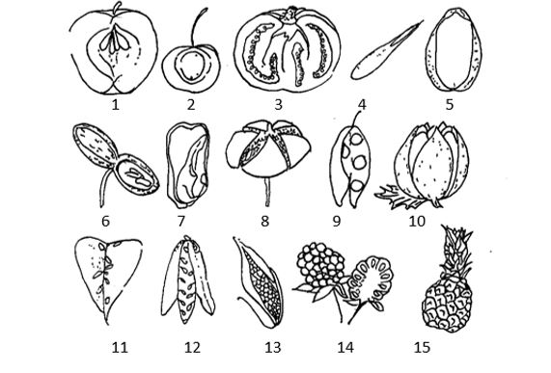

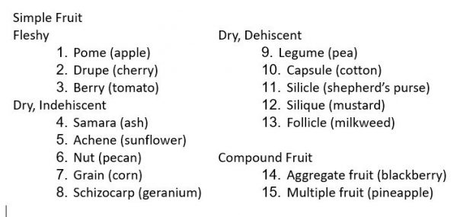

In addition to an important feature for identification purposes, many fruit types have decorative value and may provide long season interest in the landscape. The morphology of different fruit types can be examined at this link to Fruit Types KPU.ca/Hort [PDF] [New Tab].
For the majority of gymnosperms, the cone is the reproductive structure. Most familiar is the female cone, which is constructed of many small, rounded, scale-like structures attached to a central stem. The pollen bearing male cone is characteristically smaller than the female cone. Typically, a naked seed will develop on each of the scales of a female cone. Examples of recognizable cone characteristics for some closely-related conifers are available at this link to Conifer Cones – Tree Guide UK [New Tab].

Match the flower and inflorescence types.

An interactive H5P element has been excluded from this version of the text. You can view it online here:
https://kpu.pressbooks.pub/plant-identification/?p=299#h5p-42

Select and place the correct term next to the plant that has that fruit type. Search the type of fruit for each plant at this link to the
.

An interactive H5P element has been excluded from this version of the text. You can view it online here:
https://kpu.pressbooks.pub/plant-identification/?p=299#h5p-43

17

Plant Family Characteristics

Learning Objectives
- Describe key morphological patterns characteristic to plant families.

Plant families are separated according to structural differences in flowers, fruit, and seed. Genera that share similar structures are grouped within a particular family. While some plant families, such as Orchidaceae (orchid) and Asteraceae (sunflower family) have several hundred members, others such as Ginkgoaceae (ginkgo) have a single member. As the group with the greatest number of closely related plants, the family taxon provides a starting point for narrowing the search for an unknown plant. In addition to shared morphological characteristics, the family taxon provides information about evolutionary adaptations for growth conditions as well as methods for propagation. One of the most comprehensive references for angiosperms is Flowering Plant Families of the World by V. H. Heywood (2007). The morphological characteristics for some families and genera commonly found in landscapes and gardens are summarized below. Images of the representative genera are available at this link to the KPU Plant Database [New Tab] .

Asteraceae – aster, sunflower family
One of the largest families of flowering plants is the aster or sunflower family, Asteraceae. Most of its members are evergreen shrubs or subshrubs or perennial rhizomatous herbs, but tap-rooted or tuberous-rooted perennials, and biennial and annual herbs are also frequent. Common genera of this family include:
- Achillea (yarrow)
- Dahlia (dahlia)
- Jacobaea (dusty miller)
- Leucanthemum (daisy)
- Symphyotrichum (aster)
- Taraxacum (dandelion)
Key identifying characteristics for Asteraceae include an inflorescence that is a composite head with disc florets, (ray florets may or may not be present), and an achene-like cypsela (fruit) with a fringe of hairs or papus. The leaf arrangement may be alternate or opposite, though rarely whorled. Leaf blades are often lobed or toothed and pinnately or palmately veined.

Caryophyllaceae – pink, carnation family
The pink or carnation family, Caryophyllaceae is a large family of temperate eudicots that are mostly annual, biennial, or perennial herbs and a few subshrubs with woody stems. Many members are flowering ornamentals and some, such as Cerastium may be weedy. Common genera include:
- Cerastium (snow-in-summer)
- Dianthus (pinks, carnations)
- Lychnis (campions)
- Silene (catchflies)
Species in Caryophyllaceae are relatively uniform and recognized by non-succulent stems, swollen stem nodes, and opposite leaves (rarely whorled). Leaf blades are typically simple, lanceolate with entire margins, and without stipules. Flowers are often white or pink, with 4 or 5 petals, and 5 sepals. Petals may be entire, fringed, or deeply cleft and sepals may be free or united. There are usually 5-10 stamens or more and the carpels are united in a common superior ovary. Flowers are terminal and bloom singly or branched in cymes. In some species such as Silene spp., the calyx may be cylindrical and inflated. The fruit is a capsule with many seeds.

Ericaceae – heather family
One of the most common groups of plants in the British Columbia and the Pacific Northwest (PNW) is the heather family, Ericaceae. Family members are mostly temperate woody shrubs and trees, and rarely herbs. Species of Arbutus, Arctostaphylos and Gaultheria are indigenous to the PNW. Some common genera in the Ericaceae family include:
- Calluna (heather)
- Erica (heather or heath)
- Pieris (lily-of-the-valley shrub)
- Rhododendron (including azaleas and rhododendrons)
- Vaccinium (huckleberries and cranberries)
For the most part, ericaceous plants have urn-shaped flowers borne in racemes or panicles. Rhododendron is an exception; they have relatively open, bell-shaped flowers in short racemes (trusses). Other shared characteristics include: fine, off-white shallow roots, an affinity for acid soils, leathery leaves arranged alternately or appearing terminally whorled, rough or peeling bark, and dense wood. While many members are deciduous, genera in this family are among the most recognizable of broadleaf evergreens, both in and out of flower.

Lamiaceae – mint family
The mint family, Lamiaceae is easily recognized because its members exhibit square stems, opposite, often decussate (4-ranked) leaf arrangement, and distinctive two-lipped flowers held in verticillasters (pairs of axillary cymes arising from opposite leaves or bracts and forming a false whorl). The fruit is a nutlet. Family members may be annual or perennial, and are often subshrubs (woody base with soft wooded stems) or entirely herbaceous. Many are highly aromatic, vigorous growers and adapted to propagate easily from stem-cuttings. There are a number of broadleaf evergreen members in Lamiaceae, as listed below:
- Ajuga (carpet-bugle)
- Lamium (dead nettle)
- Lavandula (lavender)
- Rosmarinus (rosemary)
- Salvia (sage)
- Thymus (thyme)

Liliaceae – lily family
Members of the the lily family, Liliaceae are typically perennial herbaceous monocots that grow from bulbs or rhizomes. Leaves are basal, alternate, and sometimes whorled in arrangement with parallel venation. The inflorescence is a raceme or solitary flower. Flowers are radially symmetrical with parts occurring in 3’s, and separate but undifferentiated sepals and petals (tepals) that may be spotted or striped. The fruit is a capsule. Some of the genera in the lily family include:
- Erythronium (fawn lily)
- Fritillaria (chocolate lily)
- Lilium (lily)
- Tulipa (tulip)

Ranunculaceae – buttercup family
The buttercup family, Ranunculaceae is composed of herbaceous annuals or perennials, woody shrubs, and lianas. Leaves are typically alternate, sometimes opposite in arrangement, and simple or compound with lobed or dissected margins. The inflorescence is a cyme or solitary flower. Flower sepals and petals are often similar, separate and radially symmetric. Flowers may have few to many petals, often with many stamens and carpels, and produce follicle fruit. Examples of genera in the buttercup family are:
- Aquilegia (columbine)
- Clematis (leather flower)
- Delphinium (larkspur)
- Helleborus (hellebore)
- Ranunculus (buttercup)

Rosaceae – rose family
The rose family, Rosaceae is a large and important family of woody and herbaceous, deciduous and evergreen plants. It is valued for its bush and tree fruits and for many popular horticultural ornamental plants. A few commonly grown rosaceous plants include:
- Cotoneaster (cotoneaster)
- Fragaria (strawberry)
- Malus (crabapple)
- Spiraea (spirea)
Common features of these genera include simple rotate flowers with 5 separate petals, sepals, and stamens, and simple or multiple fleshy or achene fruits. Leave are alternate or basal in arrangement, simple or compound, sometimes toothed and often with stipules. Spines, thorns, and prickles are prevalent in the rose family.

Sapindaceae – soapberry family
The soapberry family, Sapindaceae is a large family of about 140 genera of trees and shrubs, lianas, and vines. Family members such as maples and buckeyes are valued for lumber and ornament. A few examples of sapindaceous plants include:
- Acer (maple)
- Aesculus (buckeye, horse chestnut)
- Koelreuteria (golden rain tree)
Some genera in Sapindaceae, including Acer (maple) are lactiferous, i.e. containing a milky sap. Maples and buckeyes include mostly deciduous trees and shrubs with petiolate, opposite leaves that are often simple, lobed or dissected, or pinnate, ternate, or palmately compound. Leaf venation is palmate or pinnate and leaflet margins may be entire, crenate, serrate, or dentate. The flowers are unisexual or bisexual in racemes, panicles or corymbs. The fruit is typically a distinctive samara in the maples, while the buckeyes produce globular dehiscent capsules with poisonous nuts.
There are several hundred plant families and comprehensive information about additional families is available at this link to the Digital Atlas of Ancient Life Overview of Angiosperm Phylogeny [New Tab].

Review: Identify the family name for each plant genus.

An interactive H5P element has been excluded from this version of the text. You can view it online here:
https://kpu.pressbooks.pub/plant-identification/?p=133#h5p-29

II

Part 2 Plant Requirements and Use

18

Plant Habitats

Learning Objectives
- Identify plants used in all segments of horticulture.

The horticultural use of plants for decoration, food, medicine, and materials spans the history of human development on earth. While early European explorers to North America described the new world as untouched wilderness, generations of Indigenous residents used plants for decoration and ritual and managed growing conditions for food for thousands of years. The relationship between people, plants, and the environment on the Pacific coast of North America is described at this link to the Garry oak ecosystem [New Tab].
The early European plant explorer, Archibald Menzies has been credited as the first discoverer, describer, and collector of a number of plants whose provenance is the Pacific Northwest. Provenance refers to the populations of plants that occur naturally in local regions. For example, Pseudotsuga menziesii (Douglas fir) and Arbutus menziesii (Pacific madrone) both occur naturally in the Pacific Northwest. A plant’s nativity or provenance can be determined either geographically or politically. Acer saccharum (sugar maple), is native to central eastern North America, in other words, a Canadian native, but not a Pacific Northwest native. Similarly, Artemisia tridentata (big sagebrush) and Rhus glabra (smooth sumac) are native to interior British Columbia, but only to the dry interior valleys, not to the coast.

Native Plants
Plants that occur naturally in a place are considered native or indigenous to a place. Native plants have undergone genetic adaptations that have allowed them to evolve within the physical, chemical, and biological conditions of local ecosystems. As such, they function as part of a biodiverse community of organisms that includes plants, animals, and microorganisms adapted to local environmental conditions.
In North America, an indigenous designation is usually applied to plants that were present before first contact with Europeans. Thus, Plantago spp. (plantains), although widespread here, are not considered native since they were brought here as a result of immigration by early European settlers. However, the influences of climate change and globalization will likely redefine what it means to be indigenous.
Native gardening with indigenous plants that are appropriate to the conditions and geography of a given area can simulate the biodiversity of a natural habitat. Native plant gardens locally frequently include plants that are not native to the Lower Mainland of British Columbia, but also include plants native to other parts of the Pacific Northwest. For instance, Quercus garryana (Garry oak), also discovered and described by Archibald Menzies, is now grown in gardens in the Lower Mainland, but is only found naturally in rain shadow climates, such as on southern Vancouver Island.
While not all native plants may be garden worthy for ornamental impact, those chosen from the regional locality of a garden will often blend appropriately and will be among the best adapted to local moisture, soil, and climatic conditions. Although native plants are not immune to pest and disease problems, the majority of locally native plants seem to attract fewer problems than many exotics do. Efforts to restore natural habitats using provenance-specific plants grown from locally sourced seed perform better than non-natives when established in these areas. However, changing climate patterns and the impacts of urbanization will likely have consequences for plant provenance.

Natural Habitats
Natural habitats provide the resources that enable indigenous plants to persist and thrive in existing growing conditions. Examples of natural habitats commonly used as horticultural garden themes include alpine, woodland, Mediterranean, and bog. The growth characteristics of plants native to these habitats have been shaped by differences in elevation, temperature range, precipitation, soil types and geology, and biological and chemical factors. Over time, indigenous species successfully adapted to the habitat conditions by developing specialized features for survival. Some features associated with alpine, woodland, Mediterranean, and bog plants are described below. Additional information about how evolution and natural habitats have influenced plant adaptations is available at this link to the Missouri Botanical Garden [New Tab].

Alpine plants
True alpine plants are well adapted to the harsh environments of high elevations. Above tree line, low temperatures, high sunlight, constant wind, dryness, and a short growing season are typical. Plant adaptations include growth low to the ground, a compact cushion or mat habit, and thick, waxy evergreen or pubescent (hairy), or curly leaves. Alpines, such as Campanula spp. (bell flower) flower in late spring and early summer and may have deep or extensive roots or below ground storage organs to persist in thin, low nutrient mountain soils. Although well adapted for extreme temperatures, alpine plants are typically intolerant of constant wetness around the roots and warm and humid summer conditions. Information about these specialized plants is available at this link to Alpine plant [New Tab].

Woodland understory plants
The temperate woodland habitat is characterized by distinct growing seasons, a dormant period, relatively consistent precipitation, and rich soils. Trees dominate this habitat forming an overhead canopy that shades and cools the understory and forest floor to varying degrees. Woodland understory plants include layers of woody shrubs and herbaceous plants that are adapted in size, form, shade tolerance, and slow growth or dormancy when light and water are limited. Understory plants such as Hydrangea quercifolia (oakleaf hydrangea) flower in late winter to early summer, before the leaves of deciduous shade trees fully emerge. Depending on the amount of light available, some understory plants have distinctive leaf color and patterns of ornamental interest in gardens. Information on gardening with woodland understory plants is available at this link to In the Shade: Gardening with Native Plants from the Woodland Understory [New Tab] .

Mediterranean plants
Mediterranean plants, such as Cotinus coggygria (smoke bush) and Lavandula spp. (lavender)are adapted to short, mild, and wet winters and long, warm, and dry summers. Some are short, dense, and shrubby evergreens that are suited to well drained soils, drought, and fire. Leaves may be leathery or reduced in size, and aromatic with thick, waxy or hairy coverings to reduce water loss, and bluish-grey (glaucous) or light in color to reflect excessive light. Some examples of naturally occurring vegetation are listed at this link to the Mediterranean climate Wikipedia [New Tab].

Bog plants
Bogs and freshwater habitats are typically oxygen and nutrient poor with acidic pH conditions. Quercus palustris (pin oak) is an example of a tree that naturally grows in these conditions. Bog plants are adapted to growing in standing water while marginal plants such as Iris siberica (Siberian iris) and Typha spp. (cattail) thrive in waterlogged soils and shallow waters with short term dryness. Some bog and marginal plants such as Juncus effusus ‘Spiralis’ have striking foliage and make good choices for planting areas with limited or poor drainage. The bog habitat is described at this link to Bog [New Tab].

19

Plant Use Categories

Learning Objectives
- Describe horticultural plant use categories.

Horticulture production provides plant resources for a wide range of functional, cultural, and aesthetic garden purposes. Ornamental plants are used for environmental enhancement, food production, and re-vegetation of damaged ecosystems, as well as for their visual and sensory appeal in landscapes and gardens. An overview of the ornamental horticulture sector in Canada is available at this link to the Canadian Ornamental Horticulture Alliance [New Tab]. Some common categories of plant use include bedding plants and cut flowers, trees and shrubs, and ground covers and climbers.

Bedding plants and Cut Flowers
Bedding plants, such as Lobelia erinus (lobelia) and Petunia × hybrida (petunia) are grown in greenhouses and nurseries for seasonal interest in gardens and landscapes. They are typically tender and half-hardy annuals, biennials, and some perennials that grow quickly and provide a vibrant display of color in beds, containers, and hanging baskets. Cut flowers produced by the floral industry include both herbaceous and woody flowering plants and cut greens for specialty services.

Trees and Shrubs
Trees such as Acer rubrum (red maple) and Quercus rubra (red oak) grow from single stems while some like Acer circinatum (vine maple) have two or three main stems. This distinguishes trees from shrubs with several or many stems branching from or near soil level. Whether deciduous or evergreen, trees are generally larger than shrubs however, their shape and height can vary from dwarf cultivars 1 meter high, to grafted standards on 2 meter rootstocks and specimens of 90 meters or more. Tree selection must account for mature height and spread to ensure adequate space in the landscape. Trees with year-round interest in form, foliage, flower, fruit, and bark are commonly grown in open sites as specimen plants. They may serve as a focal point for an entrance or as a special accent in the garden. On large sites, trees are often planted in groups to form woodlands or hedging. Strategic planting of trees in urban environments can channel air movement, shade and cool microclimates, and provide barriers for noise and security, as well as frame or screen views.
Shrubs such as Cornus alba ‘Elegantissima’ (silverleaf dogwood) and Hibiscus syriacus (hardy hibiscus) are valued for their ornamental features and varied growth forms. Shrub sizes range from 0.15 meter to about 6 meters. Deciduous and broadleaf evergreens, variegated foliage, fragrant and showy flowers and fruits, as well as decorative stems and buds provide year round interest and variety in mixed borders and container planting. Shrubs are commonly massed for effect, planted in small groups in mixed plantings, or used as screens and hedging. The wide selection of shrubs produced by nurseries provides for most garden conditions.

Groundcovers
Groundcover plants such as Ajuga reptans (bugleweed) are adapted with creeping and carpeting habits and are often used under woodland and shrub plantings, and for covering and stabilizing some slopes. Plant runners (stolons) that root where they touch the ground and spreading underground stems (rhizomes) that send up new shoots and form colonies stabilize and cover bare soil reducing erosion, evaporation, and weed growth.

Climbers
Climbing plants, whether woody or herbaceous, deciduous or evergreen provide strong vertical elements and year round garden interest. Where space is limited, climbers such as Hydrangea anomala ssp. petiolaris (climbing hydrangea) may be the best option for screening and climate control. It is important to match the vigor, method of attachment, height, and spread of a climber with an appropriately sturdy support and adequate light exposure for flowering and fruiting.

20

Plant Growth Characteristics

Learning Objectives
- Recognize and describe plant growth characteristics.

Plant form and growth habit are among the most noticeable and important features for identification purposes as well as for landscape plant selection. Plant form, the three-dimensional shape or silhouette outline of a plant, is determined by the habit or branching pattern. For example, plants with an excurrent growth habit have single, undivided trunks and lateral branches that typically produce an overall cone or pyramid-shaped form. This plant form and growth habit is characteristic of many gymnosperms such as Thuja plicata (western red cedar) and Pseudotsuga menziesii (Douglas fir). In contrast, decurrent, or sometimes called deliquescent growth habit exhibits several roughly equal branches arising from the trunk or stem that become the main structural system of the plant. This habit results in the typical rounded or spreading form of deciduous trees such as Acer macrophyllum (big leaf maple) or Acer platanoides (Norway maple) as well as many shrubs. Depending on the branching pattern, additional descriptive terms such as upright or horizontal, arching or weeping, open, twiggy or dense may be used for shrubs as well as for trees.

Describe plant form and habit. Click the image hotspots.

An interactive H5P element has been excluded from this version of the text. You can view it online here:
https://kpu.pressbooks.pub/plant-identification/?p=143#h5p-24

Stem, Bark, and Bud Morphology
In addition to plant form and habit, the winter identification of deciduous trees and shrubs depends on the morphology of stems, bark, and buds. Stem color, surface texture and the presence of lenticels, small cork-like spots for gas exchange between plant tissues and air are characteristic for some species of Prunus (cherry). A cross section taken through a stem or shoot reveals soft plant tissue, the pith. The color and texture of the pith may be used for distinguishing between similar plant types, such as species of Cornus (dogwood). Pith may be brown or white, variably shaped, and uniformly solid, chambered or hollow as illustrated in Figure 20.1.

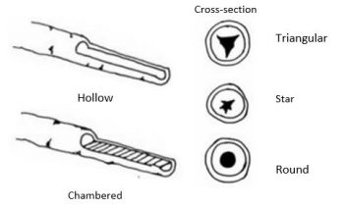

Bark, the dead outer protective tissue of woody plants can vary greatly in appearance, thickness, and texture as a tree or shrub matures. In addition to plant identification, plant bark may have highly ornamental value in the landscape. Color change, peeling and exfoliation, and smooth, or furrowed (grooved), ridged or plate-like are some common descriptors used for bark. For example, Figure 20.2 shows the bark of Platanus × acerifolia . In addition to its ornamental value, the bark is a key identification feature for this tree.

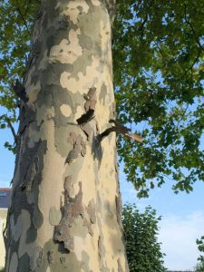

Buds, condensed shoots containing a new leaf, leaf cluster, or flower are located in leaf axils and at tips of stems. In general, a flower bud appears somewhat larger and rounder than a vegetative bud. While bud shape, size, color, and surface texture vary by species, bud arrangement will be alternate, opposite or whorled on the stem. Bud scales, the protective covering of buds may be single, few, or many, and imbricated (overlapping) or not as shown in the Figure 20.3. The shape of a leaf scar, where a leaf falls off a twig, and the arrangement of vascular bundles within the leaf scar may also provide distinct identification characteristics as in Juglans spp. (walnut).

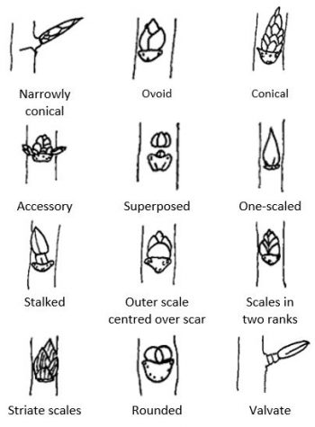

The dichotomous key below differentiates bud characteristics for some common deciduous trees and shrubs. Plant information is available at this link to the KPU Plant Database [New Tab].

Dichotomous Key to Buds of Common Deciduous Trees and Shrubs
- 1.a. buds opposite or whorled on the stem ……………………………………………………. go to 2
- 1.b. buds not opposite on the stems ……………………………………………………………… go to 7
- 2.a. leaf scars oval or round, vein scars forming a ring ……………………. Catalpa speciosa [New Tab]
- 2.b. leaf and vein scars not as above ……………………………………………………………… go to 3
- 3.a. buds valvate, appressed, brownish black ………………… Cornuskousa var. chinensis [New Tab]
- 3.b. buds acute or swollen, red or green ……………………………………………………….. go to 4
- 4.a. buds small or narrow, with few obvious scales, the scales more or less valvate (i.e., meeting at the edges) …………………………………………………………………………….. go to 5
- 4.b. buds large, with several imbricate (overlapping) scales ………………………….. go to 6
- 5.a. buds conical, the outer scales shiny red, the bud with a short fringe of hairs at its base…………………………………………………………………………………………………. Acer circinatum [New Tab]
- 5.b. buds conical, the outer bud scales green or red, hairs extending half the height of the bud…………………………………………………….. Acer palmatum Atropurpureum Group [New Tab]
- 6.a. buds brown large, ovoid, and varnished with sticky gum ……………………………………………………………………………………………. Aesculushippocastanum [New Tab]
- 6.b. buds smooth, leaf scars small, with a single vein scar………………… Syringa vulgaris [New Tab]
- 7.a. buds narrowly conical and bud scales imbricate ………………………… Fagus sylvatica [New Tab]
- 7.b. the bud scales imbricate or valvate, or the buds covered by a single scale …………………………………………………………………………………………………………………….. go to 8
- 8.a. buds stalked ……………………………………………………………………………………. Alnusrubra [New Tab]
- 8.b. buds not stalked ……………………………………………………………………………………. go to 9
- 9.a. twigs yellow, the buds flattened, appressed to stems and covered by a single, silky-downy bud scale…………………………………………… Salix sepulcralis var. chrysochoma [New Tab]
- 9.b. twigs not yellow, buds not covered by a single scale ……………………………. go to 10
- 10.a. lateral buds superposed, slightly hairy; leaf scars v-shaped, prominent; pith chambered ………………………………………………………………………………………….. Juglansnigra [New Tab]
- 10.b. buds not superposed; leaf scars not v-shaped; pith not chambered …………………………………………………………………………………………………………………… go to 11
- 11.a. buds 2 mm long, rounded to shortly acute, with several reddish-brown scales ……………………………………………………………………………………………………… Cotinuscoggygria [New Tab]
- 11.b. buds 2 mm long, ovoid to acute, with several rows of imbricate scales …………………………………………………………………………………………………………………… go to 12
- 12.a. buds of 2 sizes, bud scales glabrous, leaf scars triangular with 3 vein scars ……………………………………………………………………………………………………….. Prunus ‘Kanzan’ [New Tab]
- 12.b. buds of 1 kind; buds scales fringed with hair; leaf scars with 5 or more vein scars …………………………………………………………………………………………………. Quercusrobur [New Tab]

21

Characteristics of weedy species

Learning Objectives
- Describe the characteristics of weedy species.

Whether a plant is classified as a weed or not depends on its location and relationship to human activities. Plants in gardens, agricultural, and natural settings that are considered undesirable or out of place due to appearance, contamination, or competition with desirable plants are often classed as weeds. Aquatic and terrestrial weedy species transported or migrated beyond their natural range that become established in a new area may pose significant impact or injury to economic, environmental, or human health. These are categorized as invasive, noxious, or nuisance species by governing authorities. Examples of species monitored for management in British Columbia are listed at this link to Invasive Terrestrial Plants [New Tab].
Common characteristics of weedy species include aggressive growth, competition with other plants for light, water, nutrients, and space, an ability to grow in a wide range of soils and adverse conditions, and resistance to control measures. Some cultivated plants such as Lythrum salicaria ( purple loosestrife), Vinca minor (periwinkle) and Lamiastrum galeobdolon (yellow archangel) can overwhelm and displace other plants and ecosystems. A number of unwanted horticultural plants are identified in this link to the Field Guide to Noxious Weeds and Other Selected Invasive Plants of British Columbia [PDF] [New Tab].
When environmental conditions in a site change there will always be a change in the plant make up. For instance, where the ground is fully covered with vegetation there will be no bare soil available for weeds to inhabit. Disturbances in vegetation cover and changes in environmental conditions due to natural events or human activities and management practices create opportunities for species with adapted life cycles and growth characteristics to become established, reproduce, and colonize a site.
Knowledge of family characteristics and life cycles is important for proper landscape and garden plant selection. Species characteristics such as generalist pollination requirements, diverse seed and vegetative dispersal methods, the ability to adapt quickly to new environmental conditions may indicate the potential for invasive growth. Combinations of these characteristics are commonly exhibited in the Asteraceae (aster), Brassicaceae (mustard), Polygonaceae (knotweed), Fabaceae (pea), and Euphorbiaceae (spurge) families, as well as others.
Weeds are typically classified according to their life cycle. Depending on the degree of disturbance to a site, herbaceous plant species with annual and biennial life cycles will be the first to colonize followed by perennial herbaceous and woody plants. Annual weeds such as Galium aparine (cleavers) that produce high numbers of seed occur most frequently in regularly cultivated and disturbed areas such as vegetable gardens or annual borders. Their rapid growth can smother slower-growing plants and compete for moisture and light. An advantage for winter annuals such as Capsella bursa-pastoris (shepherd’s purse) and Cardamine oligosperma (snapweed) is that they germinate in the fall, overwinter as a rosette of leaves, and flower and produce many seeds in late winter and early spring. Biennial weeds such as Echium vulgare (blueweed) usually produce only a rosette of leaves in the first growing season. Energy stored in the roots over a winter cold period enables the plant to bolt (flower), produce seeds, and then die in the next season. Removal of the rosette before flowering stops the biennial life cycle.
Herbaceous perennial weeds such as Cirsium vulgare (Canada thistle), Heracleum mantegazzianum (giant hogweed), and Equisetum arvense (horsetail) and woody species such as Buddleja davidii (butterfly bush) and Rubus armeniacus (Himalayan blackberry) survive adverse conditions by storing food reserves in roots, rhizomes, and tubers or bulbs in some species. Important control measures include early identification and removal before establishment.
In situations where weed populations remain below established thresholds of impact or injury for a given site and use, there are ecosystem benefits. For instance weed cover can provide protection from soil erosion, produce pollen, nectar, and habitat for beneficial organisms and wildlife, serve as indicators of soil conditions, and contribute organic matter for soil enhancement, as well as provide food and medicinal products for human use.

For each plant, access the correct common name and family name available at this link to the

An interactive H5P element has been excluded from this version of the text. You can view it online here:
https://kpu.pressbooks.pub/plant-identification/?p=145#h5p-30

22

Plant Hardiness

Learning Objectives
- Explain plant hardiness zones.

Over the course of their evolution, plant species adapt to the climate variations of a region. Therefore, the ultimate deciding factor in whether a plant will survive in a given location (with adequate supplies of light, moisture, and nutrients) is quite simply the lowest temperature it will have to endure. Although several factors such as length of frost free period, rainfall, snow cover, wind, and soil type affect the hardiness of a plant, in temperate climates the minimum temperature during the winter is the most important element in plant survival.

Plant Hardiness Zones
Average annual minimum temperatures are determined for locations throughout North America. Plotting areas with similar average minimum temperatures yields a temperature zone map. Zones numbered 0 to 9 relate to the average annual minimum temperature calculated for that zone. The zones are divided into “a” and “b,” the “b” area representing the mildest part of the zone. Plants designated “a” with the zone number are hardy in the colder part of that zone; those designated “b” in only the milder section.
Plant hardiness ratings are determined by testing over several years at agricultural research and testing stations as well as private nurseries and gardens. A plant which is hardy to a particular zone can be expected to survive in all regions on the map which have an average annual minimum temperature equal to or greater than the hardiness zone rating for that plant.
Currently, two hardiness zone maps are widely used in North America:
- Agriculture Canada
- United States Department of Agriculture (U.S.D.A.)
In Canada, horticulturists often refer to the Agriculture Canada hardiness zone map. It is similar to the U.S.D.A. system except that the temperature range for each of the 9 zones is given in degrees Celsius instead of degrees Fahrenheit. Table 22.1 lists examples of hardiness zones for some Canadian communities.

Table 22.1: Hardiness zones for Canadian communities
Location | Zone
Edmonton, Alta. | 2
Prince George, B.C. | 3
Ottawa, Ont. | 3
Fredericton, N.B. | 5
Langley, B.C. | 7
Vancouver, B.C. | 8

A map that outlines all of the different zones is available at this link to Canada’s Plant Hardiness Zones [New Tab].
Horticulturists in the United States most commonly use the U.S.D.A. map. It divides the United States into 13 zones based on the average annual extreme minimum temperature with zone 1 being the coldest (-60 F.) and zone 13 being the warmest (above 60 F.). It is included in many books and catalogs, and is available at this link to the USDA Plant Hardiness Zone Map [New Tab].

Changing Climate Means Changing Hardiness Zones
Natural Resources Canada updated the plant hardiness zones map to include, among other factors, the effects of elevation on plant hardiness. The update provided evidence that there have been marked changes in hardiness zones in Western Canada. While the map expanded the factors affecting plant hardiness, local variability in topography, shelter, and snow cover were not captured. In an effort to increase knowledge about the effect of changing climate climate on the range of species growth in different locales, Natural Resources Canada created an interactive zone map where experts and gardeners contribute information about plant survival at this link to Canada’s Plant Hardiness Site [New Tab].

Identify the hardiness zone for each plant available at this link to the
.
An interactive H5P element has been excluded from this version of the text. You can view it online here:
https://kpu.pressbooks.pub/plant-identification/?p=147#h5p-44

23

Plant Requirements

Learning Objectives
- Identify plant requirements for woody and non-woody plants.

Although plants established in cultivated gardens and landscapes are not the result of long-term evolution, the concept of “right plant, right place” can be effectively applied in these settings. Plant selection and placement that matches a species growth characteristics with existing conditions and available maintenance requirements supports healthy growth and vigor.
Cultural requirements are defined as site conditions that influence plant growth and longevity. Conditions typically include diverse combinations of light exposure, moisture conditions, soil types and nutrient availability, and hardiness zones. Depending on the site, conditions may also include plant tolerance for wind, salt, and drought. While garden plants require some routine maintenance for healthy growth, proper plant selection and planting practices decrease unsustainable maintenance inputs and reduce incidences of pest and disease and plant failure or death.
Maintenance requirements are related to factors that influence plant growth and development. Light exposure is typically classified as full (six or more hours of direct sunlight per day), part (four to six hours of sunlight) or part shade (two to fours hours of sunlight), and shade (less than two hours of sunlight per day). Water requirements and existing moisture conditions range from dry or xeric, to well-drained, and poorly drained or wet depending on the amount of rainfall or irrigation, the site slope, and the soil type. Soil drainage will be influenced by the amount and arrangement of particles of sand, silt and clay. Gravel or sandy soils tend to drain rapidly and have low nutrient levels because they are made up of relatively large particles with large pores or spaces between them. In contrast, clay and silt soils are composed of tiny particles separated by minute spaces that tend to retain nutrients and drain more slowly. Garden loam that is fertile and well drained is the result of a balanced combination sand, silt, and clay.
Information from resources about plant growth requirements for light, water, soils and nutrients combined with knowledge of prevailing conditions and smaller-scale garden variations in temperature, air quality, wind, and humidity, and environmental stresses or pests and disease supports the identification of the right plant for the right place.

Identify plant requirements for light exposure, soil type, and water use available at this link to the
.

An interactive H5P element has been excluded from this version of the text. You can view it online here:
https://kpu.pressbooks.pub/plant-identification/?p=149#h5p-45

