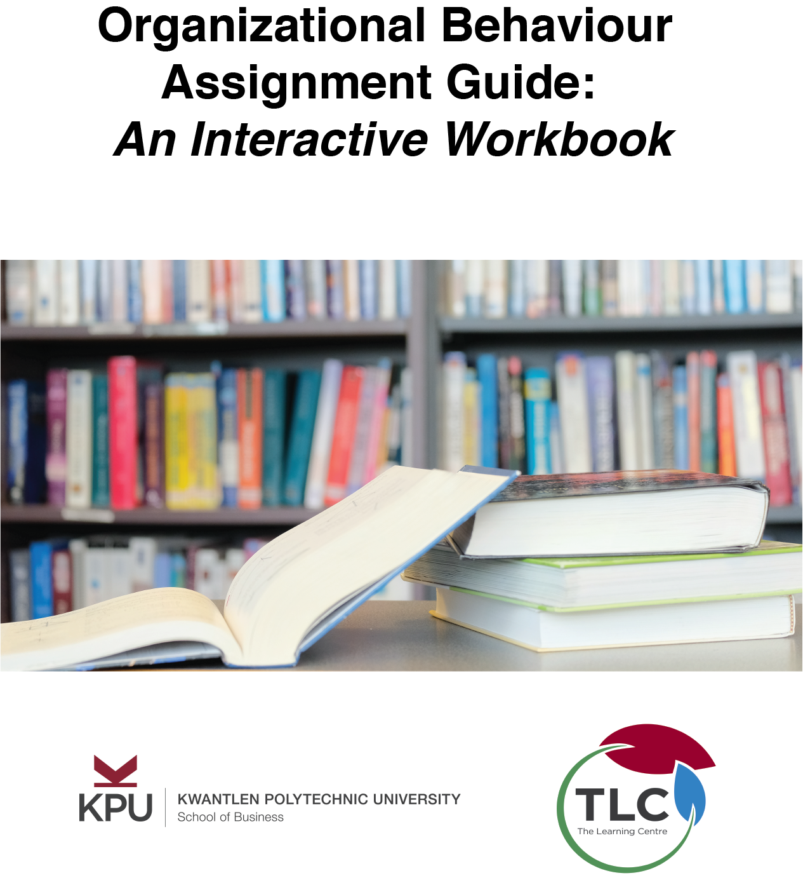

Organizational Behaviour Group Project Workbook

Organizational Behaviour Group Project Workbook

Christina Page, Lesley McCannell, and Andre Iwanchuk

Organizational Behaviour Group Project Workbook by Christina Page, Lesley McCannell, and Andre Iwanchuk is licensed under a Creative Commons Attribution-ShareAlike 4.0 International License, except where otherwise noted.

Contents
- Introduction
- Project Overview
- Assignment Guidelines
Christina Page and Lesley McCannell
- Case Study
Lesley McCannell
- Rubric
Christina Page and Lesley McCannell
- How to Be Successful
Lesley McCannell
- Weekly Tasks and Tools
- Task 1: Analyze the Case and Identify Challenges
Christina Page
- Task 2: Develop a Group Charter
Lesley McCannell
- Task 3: Identify Research Topics
Lesley McCannell and Christina Page
- Task 4: Conducting Your Research
Andre Iwanchuk
- Task 5: Take Notes from Research
Christina Page
- Task 6: Write Your Research Summaries
Christina Page and Lesley McCannell
- Task 7: Develop Recommendations for Challenge Area 1
Christina Page and Lesley McCannell
- Task 8: Develop Recommendations for Challenges 2-3
Christina Page
- Task 9: Draft Your Report
- Task 10: Format and Polish Your Report
Christina Page
- Appendix

The first step to success in a major business or academic project is understanding what you need to do. This section of your workbook includes the instructions for your project, tools for understanding the task well, and tips for success.
It may seem tempting to skip this section and begin working on the project tasks. This can be a risky strategy — sometimes people find they work hard on a project, only to find that they haven’t satisfied the requirements.
By investing time into understanding the tasks ahead of you, you will be prepared to create an effective plan and to meet the requirements of your project.
Let’s begin.

PART I

Project Overview

Chapter 1

Assignment Guidelines

Christina Page and Lesley McCannell

Learning Objectives
By the time you complete this section of the workbook, you will have
- Read the guidelines for your group project
- Demonstrated your understanding of the task by completing a short quiz

Why Analyze Assignment Guidelines?
Many students skim assignment guidelines quickly, eager to get started on the project work. Why spend additional time analyzing the assignment guidelines?
In order to do a task well, you need to understand what is being asked of you. This includes understanding the purpose of the assignment. Why are you doing this task? It also includes understanding the content of the assignment. What do you need to research and write? Lastly, it is important to understand the format of the assignment. How do you need to present your work?
Read the assignment guidelines below. At the end of the page, you will complete a brief quiz to determine how well you have understood your task. (Hint: You can use the arrow on the bottom right hand corner of the activity to view it in full screen mode).
An interactive or media element has been excluded from this version of the text. You can view it online here:
https://kpu.pressbooks.pub/obprojectworkbook/?p=28

The purpose of this group project is to provide an opportunity to apply research and analytical skills to address the organizational behaviour-related challenges facing an individual and an organization. Click here to read the Case Study that this assignment is based on. You’ll probably want to print a copy of the case and keep it handy while you work on this assignment.
As a team you will identify challenges, research potential innovative solutions and provide Eva with detailed recommendations and action plans relating to three different challenges she is facing. The deliverables produced for this assignment include:
- Project charter/plan and selection of three challenges your team will focus on (e.g. leadership, motivation, change management, etc.)
- Recommendations and action plan for Challenge 1
- Recommendations and action plan for Challenge 2
- Recommencations and action plan for Challenge 3
This project has been designed in such a way as to discourage a “divide and conquer approach” and encourage a collaborative team effort. Subsequently team process and collaboration forms part of your grade for this assignment. 50% of your grade is based on your participation and 50% is based on the “product” produced by your team. My experience from running this assignment in other classes is that the team with the best group process produces the best deliverable. To read more about the “Lessons Learned” from previous classes Click Here.
Click here to access the assessment rubrics that I use when grading your work. It’s a good idea to print these as well and refer to them as you work on this assignment.
In order to facilitate the grading of your participation please ensure that all project-related communication occurs on the Group Project Discussion Forum or summary minutes are posted for all online/in-person meetings. I need to know who was there, the topics discussed and the actions that arise from each meeting.
This assignment runs over a period of five weeks – my suggestion is that you use the first week to plan the project, then focus on a different challenge area for the first 3 weeks and use the last week to pull the assignment together. Each team member must contribute research and ideas to all of the challenge areas. For each challenge area of the project your group should identify what questions (e.g. research) you need answered in order to produce the recommendations and then assign those questions to individual team members. The individual team members will conduct research, and summarize the research for the team so the group can use the information to develop the deliverable. As you work on the deliverable you may find that you have additional questions that require additional research.
Each team member must contribute a minimum of 2 pieces of research to each deliverable – you can do more. A minimum of 50% of each individual’s research must be from peer reviewed journals (e.g. library research). The research contribution should include the URL address, a summary of the information contained in the resource and how you think it could contribute to the deliverable that your group will produce. This information will be posted in the group project discussion forum for your team to use as you work on the project. Research for the “sake of research” that does not contribute to the development of the deliverable is not valuable and will be graded as such.
When the final paper is pulled together each team member should have an Appendix showcasing the research they conducted – the URL’s, the summary of the research and how you think it contributes to the project. This appendix is simply a compilation of the research that you will have completed throughout the project.
STEP 1 – GETTING STARTED
Assignment: Team Charter/Plan (1-2 pages) and Identification of three Challenge Areas to be Used as the Basis of the Assignment (3-4 sentences describing each)
All team members should read the assignment and the attached case and identify any questions that you have. Discuss them in your Group Project Discussion Forum. As a team you must build a team charter that identifies the expectations of team members – this is your “Rules of the Road” and will be used to evaluate individual participation in this project. Some questions to consider include the following:
- How often should people check the group discussion forum each week?
- How much research should individuals contribute to each stage; how will you decide who researches what area to avoid duplication; how will the group handle the situation where someone’s research does not contribute to the deliverable; if additional research is required to make your deliverable really strong how will you decide who does it?
- How will the deliverables be prepared? What are your deadlines? What is your schedule of communication?
- Will you have a project manager for the entire project, assign a leader for each section or will you operate as a self- managed team,
- Will you have a meeting time each week where people are online, etc.
- How will you address members who don’t participate or submit material late?
- Include any other expectations that you think will be helpful to ensure that your team operates effectively.
These expectations will be used to evaluate team members at the conclusion of the project. I will ask you to rate each team member’s contribution to the final product and support your ratings based on the expectations that your team set.
The team must decide on three challenge areas to use as the basis of your assignment. The challenge areas can include anything that you think Eva will need to address as she starts her new position. To identify the challenge areas I’d suggest the following process:
- Have each team member read the case and identify as many issues/challenges as possible
- Post your work to the group discussion area
- Compile the list of issues/challenges produced by the group and review the list to identify duplications or issues that could be combined
- Agree on three challenges that your team will focus on. Write a 3-4 sentence paragraph describing each challenge.
This portion should be posted in your group’s discussion area. I will provide feedback to your group in your discussion area.
STEP 2 – Challenge #1, #2 and #3
Assignment: Recommendations on how to address each of the challenge areas (5-6 pages each). Focus on 1 of these each week.
- Identify the issues/questions that need to be answered in order to build your recommendations. What don’t you know?
- Define each research question very clearly and divide the research areas among your team members.
- Post you research summaries to the discussion area and use it to develop your deliverable. Your research summary should include the reference (include the length of article), a 2-3 paragraph description of the resource and a paragraph identifying why you think this is valuable information for your group to consider when developing the recommendations
- Make any assumptions necessary to develop a comprehensive program and document any assumptions/rationales that are important for understanding your decision-making.
- Your recommendations should include: what you will do and why. Be specific, and clearly identify how it will address the issue/challenge. Use you research to support and validate your recommendations. Identify the actions required to implement the recommendation
STEP 3 – Report Preparation
Assignment: Final Report
- All deliverables must be 12 pt. font, double-spaced and not exceed the page specifications excluding title page, table of contents, references and appendices)
- Your report should include a title page, table of contents, introduction and references. Appendices that support your decisions may also be included.
- Appendix for each team member showcasing the research they conducted personally.
- Prepare your report according to APA guidelines.This report will be submitted to the Group Assignment Dropbox.​

Chapter 2

Case Study

Lesley McCannell

Learning Objectives
By the time you complete this section, you will have:
- Read your project case study to gain an overview of your task
The Gamble
Eva Peters is packing the contents of her New York City apartment and thinking about her new job. Monday morning Eva takes over as the President of the Lottery Corporation (LC) in Java, Canada. Eva has worked in the gaming industry for years and has been very successful in her latest role as CEO of Ex- Works, a manufacturer of gaming equipment. Her take charge, no-nonsense approach turned this near bankrupt company into one of the leading manufacturers in North America. Despite her experience and successful track record Eva is having doubts about her next challenge – what will she do first? – what will it be like to work in the “back woods” of Canada?
You’ve been hired as Eva’s Executive Coach to help her determine the best approach to turning the LC up-side down. The LC is an independent body created to administer and operate lottery and gaming activities on behalf of the Java Province. In addition to offering lottery games and overseeing video lottery operations, LC’s mandate includes the management of gaming technology, gaming design and financial and security controls. LC has been very successful since its creation 25 years ago.
Running the provincial lotteries has basically been a ticket to print money and annual revenues are well over the 100 million dollar range. However, their playing field has started to change. Competition for the “entertainment” dollar is on the rise and market research has shown that “gaming” competes with other forms of entertainment (e.g. movies, theatre, restaurants) for the consumer’s dollar. There are also more opportunities for people to meet their gambling needs – the number of National Games has increased (Lucky 7, 649) and e-gaming, that allows you to play 24 hours a day, is on the rise. Some experts in the field prophesy that the day of the scratch and win ticket may soon be over. For the first time in its history the organization is at a cross-roads and must make a strategic decision regarding the business they are in – do they “gamble” and remain a “lottery” organization or do they enter the quickly expanding e-gaming industry.
Although LC has a profitable track record the Board of Directors has become very dissatisfied and are ready to force big changes in the organization. They are convinced that the margins could be much higher and that the organization is not efficient or well-managed. In a rare and bold move the Board commissioned an Efficiency Study on the operations of the entire organization. Shortly thereafter the President of 25 years resigned. The Board is ready for significant change in the operation of the organization and are quickly growing impatient.
The culture of the organization has been described as warm, friendly and staff oriented. People like to work at LC. It’s the type of environment where VP’s know staff by name and take a personal interest in the well-being of individuals. Abnormally low turnover has resulted in a workforce that is very experienced and long tenured. This low turnover is attributed in part to their staff-friendly culture and their very strong preference for promoting from within. However, pockets of staff aren’t as positive and describe the culture as stagnant, complacent and not performance driven – basically a culture of entitlement. Some would say that motivation to perform is non-existent.
Most of the Senior Management team have been with LC for several years. When the organization was formed 25 years ago the most experienced and senior people filled the Executive roles and for the most part have remained with the organization since. A few of the VPs are new – one actually worked her way up in the organization from a mail clerk. Another left a partnership position in a top Toronto ad agency in pursuit of a simpler life. The Senior team is relatively cohesive although the beginnings of a rift between the “old guard” and the “new blood” is developing. The old guard is reluctant to dive into the e-gaming field and abandon the lotteries that have been the life-blood of the organization. The new blood is convinced that everyday they aren’t in the e-gaming business is a day wasted. After all, a lack of strategy has never stopped them in the past and everything the LC has tried has been successful – why would e-gaming be any different? The “power games” and politicking between these two groups are starting to take there toll on the organization. The day the President of 25 years (the only President the LC has ever had) announced his “retirement” people were crying in the hallways. Since his departure 6 months ago the organization has been in a holding pattern – some people are anxious to move ahead and others are terrified of what may be coming next. ​

Chapter 3

Rubric

Christina Page and Lesley McCannell

Learning Objectives
By the time you complete this section, you will have
- Identified the ways a rubric can help you achieve your goals in this assignment.
- Reviewed your project rubric.
- Noted key characteristics of success in this project based on your rubric.
What is a rubric?
When you receive many of your course assignments, you may also receive a copy of the rubric the instructor will use to grade your work. The rubric provides information on what criteria shape a highly successful assignment.
How to use rubrics
Your assignment instructions and rubric are two of your key tools throughout the process of completing the assignment. These provide an outline of the criteria that the instructor has set out for a successful assignment. There are two key times to use the rubric and assignment instructions:
- Before you start writing: Unfortunately, time may be lost writing something that does not meet the key guidelines you must follow. To avoid this problem, take time to read both the assignment instructions and rubric carefully before beginning. Clarify any areas of confusion with your instructor.
- After you have written a draft, but before you submit the assignment: At this point, grade your work according to the rubric. Think carefully and critically. Are there areas where you may not have met the criteria well? If so, edit your work accordingly, making the needed revisions before submitting the assignment.
The video below provides additional strategies for using rubrics. When you are finished the video, you will begin reviewing your assignment rubric, printed below the video on this page.

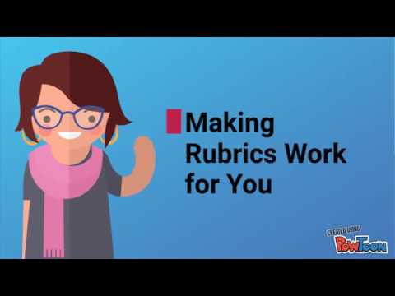
A YouTube element has been excluded from this version of the text. You can view it online here: https://kpu.pressbooks.pub/obprojectworkbook/?p=32
Assignment Rubric
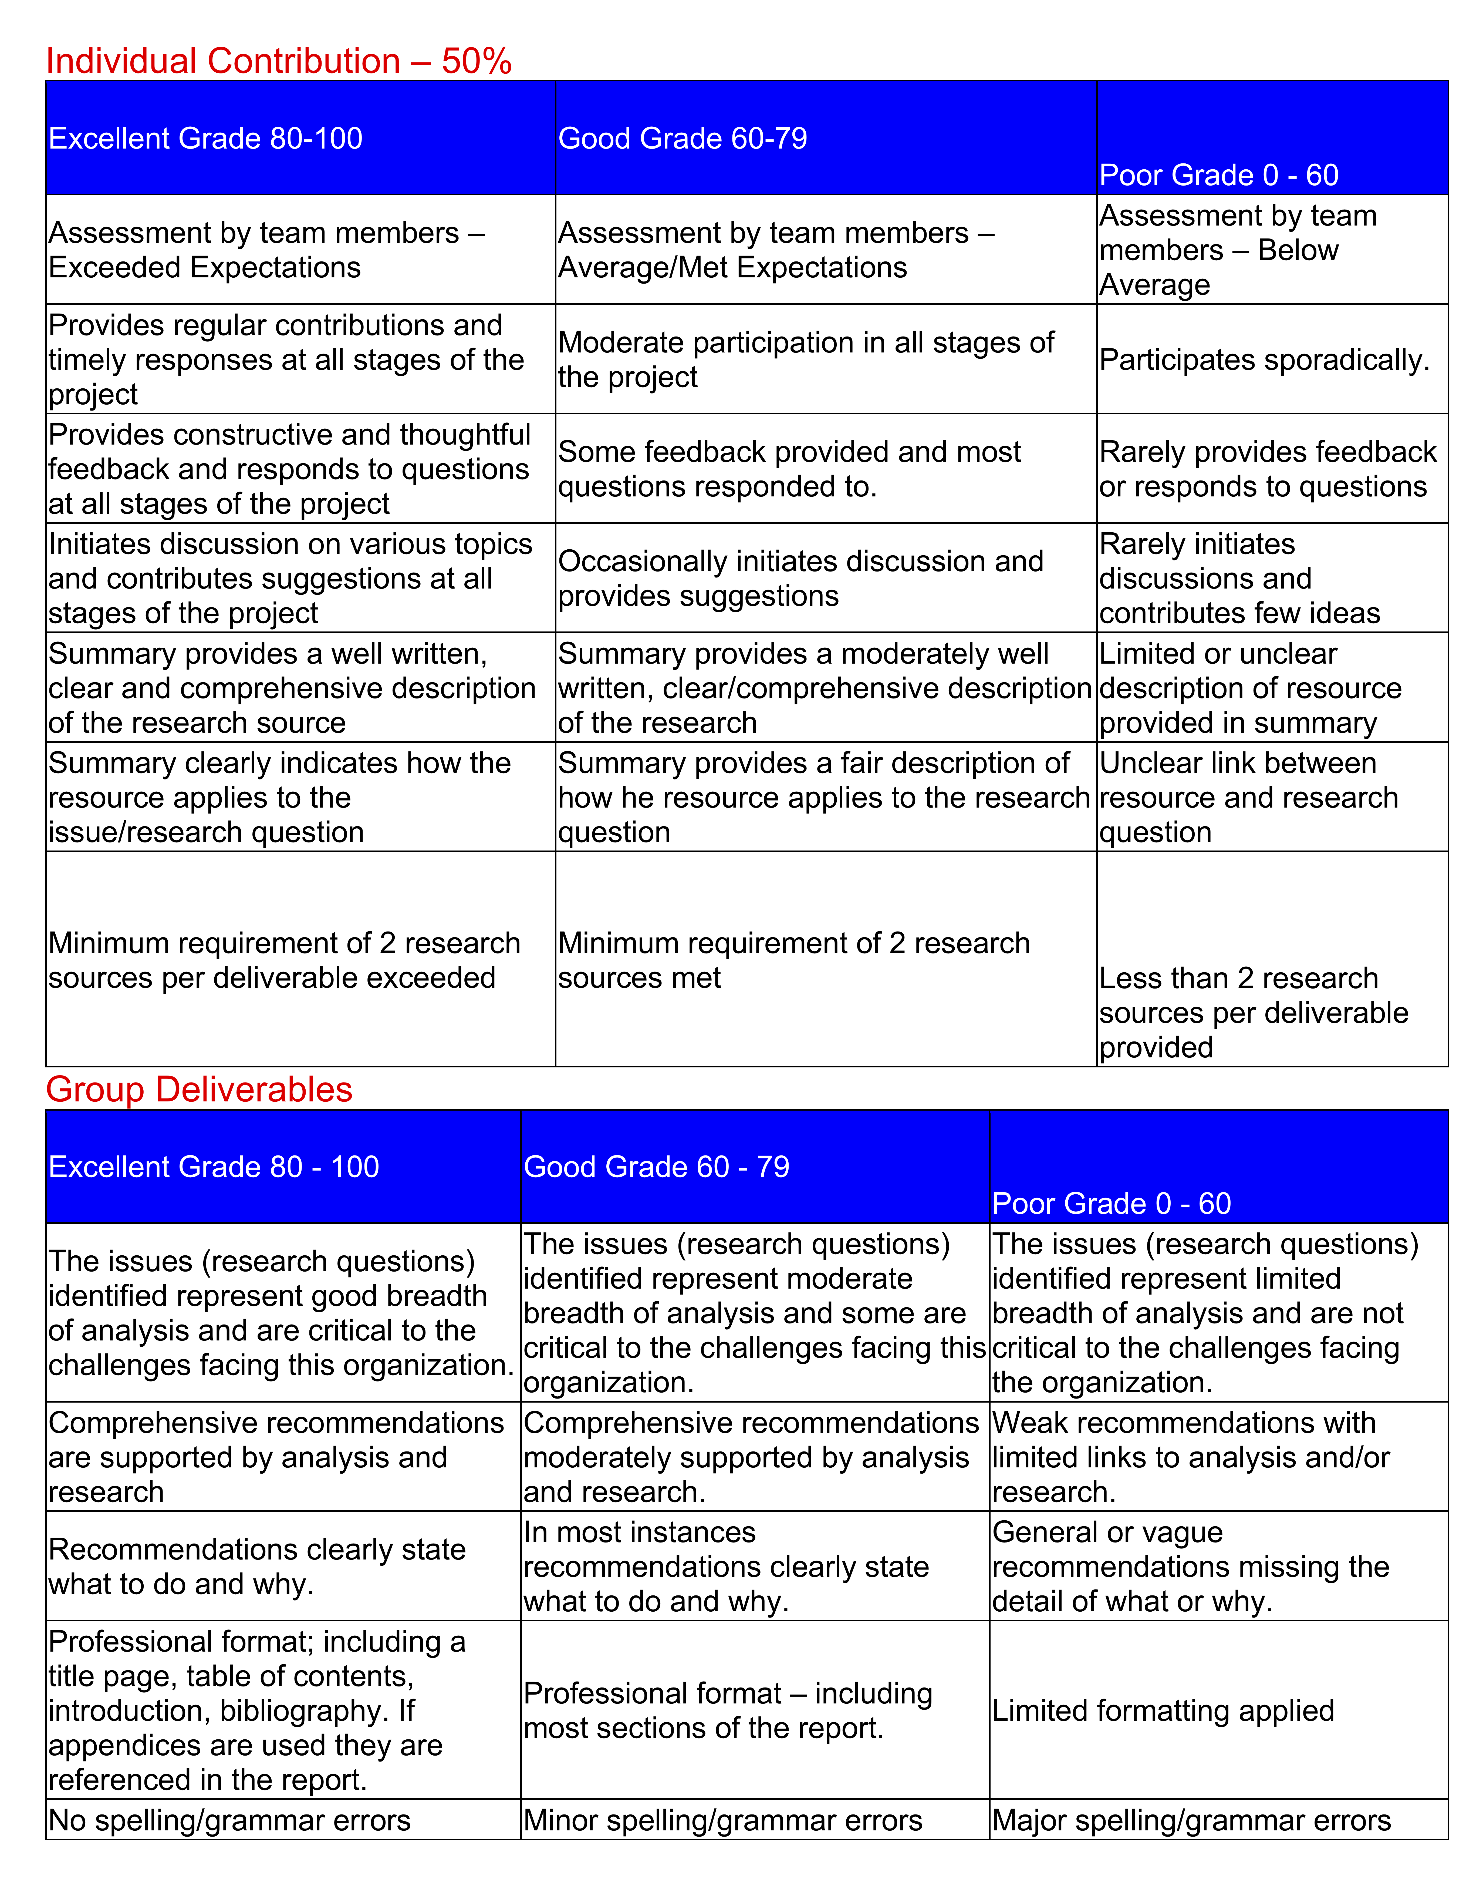
Link to PDF copy of the rubric

Chapter 4

How to Be Successful

Lesley McCannell

Learning Objectives
By the time you complete this section, you will have
- Reviewed lessons learned from previous students about project success
- Listed the keys to success that you want to personally remember
Group Project – Lessons Learned
I’ve run this assignment or similar ones several times with students and thought I’d pass on some off the things that I’ve observed about successful teams and some comments that students have made.
- The quality of the group process correlates 100% with the quality of the group product. What does that mean – in order to grade the group process part of the assignment I review the discussion forums to see who is participating, how often and the quality of the participation. Without fail the groups that worked well with one another (e.g. careful planning, clearly assigning tasks and staying in touch, etc.) score much higher on the paper they submit.
- Expect to visit the course site a minimum of 3 times a week during the group project. It’s preferable to check in daily. Checking in means checking your discussion forum to see if anyone is waiting for a response from you.
- Don’t wait to take action – be the one who initiates the discussion – when you look at the marking rubric you’ll see that I look for “initiating discussion and ideas” when I’m grading your participation.
- Everyone has to read the entire assignment thoroughly to do your initial planning. The hardest part of this assignment is getting organized!
- If you want high quality research you need to coordinate the research that people do. The most successful teams would meet early in the week, discuss the deliverable (e.g. have a chat), decide what specific research would be helpful, assign specific tasks to members and update each other mid-week. It didn’t seem to work as well when teams would say – “just go and see what you can find”. People would end up duplicating the work of others and that affects the quality of the research.
- Have the discussion about “who will write each deliverable early”. Sometimes that discussion never took place and everyone would wait to see if someone else would volunteer.
- Hitchhiking on your team members efforts is not tolerated. If a member is not performing address the situation early – ask them if they need help. If I notice that a team member is continually not contributing to the discussion and chats I will first contact them to see if something is preventing them from full participation. If they continue to not participate I will remove them from the team. If you plan to be a way for a few days you need to let your team know that. ​
An interactive or media element has been excluded from this version of the text. You can view it online here:
https://kpu.pressbooks.pub/obprojectworkbook/?p=34

PART II

Weekly Tasks and Tools

Chapter 5

Task 1: Analyze the Case and Identify Challenges

Christina Page

Step 1: Brainstorm key course concepts and make a mind map
Mind mapping which is also called “clustering ideas”, is a way of collecting ideas around a particular topic and defining connections. In the assignment process, you use mind mapping to brainstorm ideas, and to determine how these ideas are related..
Below you will find an example of a mind map. To make a mind map for this assignment, consider Organizational Behaviour as your central topic. From there, create branches for each subtopic or area that you have studied so far in the course.



Step 2: Read the Case
With your mind map beside you, read the case study. In the margins, note any relevant concepts that connect to the case.
Step 3: Ask Questions
Create a chart like the one below with some key questions to help you think analytically about the case:
Who are the main players?
What are the challenges?
What resources are available?
What are the opportunities?
What do you know?
What is unknown?
What are the pressures?
What problems are evident?
What needs to be done?
What assumptions are being made
Step 4: Consider multiple points of view
In order to generate additional ideas, consider how the case might be viewed by different stakeholders. How might Eva view the situation? How might the board view the problem? What might be the viewpoint of longtime employees?
Step 5: Analyze and Identify Relevant Challenges
Now that you have considered the case through multiple angles, identify what you think might be key challenges. Beside each possible key challenge, write the relevant concepts in the course that you have learned, and that will form the basis of your research. You will bring your analysis to your group meeting. As your group combines the ideas, you will develop a shared list of key challenges based on the strongest ideas.
Key Challenge | Course Concepts that Relate to this Challenge
1
2
3

Learning Objectives
By the time you complete this task, you will have:
- Applied a systematic approach to reviewing your case study
- Identified key challenges that you observe in the case
How to Read a Case Study
- Review the key concepts you have explored in the course. These concepts are the lens you will use to explore the case. To do this, make a mind map of key organizational behaviour concepts and how they are related
- Read the case study, and record what concepts and principles from your course might be relevant to the case. Make a note of these in the margins or on a separate sheet of paper.
- Ask yourself questions to understand the case better. Who are the main players? What are the challenges, constraints, resources, and opportunities? Each case usually has a range of information that you need to identify, including: What is known? What is unknown? What pressures exist? What is the context? What assumptions are being made? What problems are evident? What needs to be done, decided, or resolved? What biases are evident?
- Consider multiple perspectives. What might this case look like through different points of view.
- Analyze the issues to identify the most relevant challenges to research and discuss in your assignment.
Brainstorm your initial ideas about the case. You will bring these ideas to your group meeting in Task 1, where you identify challenges.

Chapter 6

Task 2: Develop a Group Charter

Lesley McCannell

Learning Objectives
By the time you complete this task, you will have:
- Developed a team charter to guide your work together
- Created a table outlining your project plan
- Collected contact information for your fellow group members
Team Charter Questions

· How often should people check the group discussion forum each week?
· How much research should individuals contribute to each challenge?
· How will you decide who researches what area to avoid duplication?
· How will the group handle the situation where someone’s research does not contribute to the deliverable?
· If additional research is required to make your deliverable really strong how will you decide who does it?
· Where will team members post their research summaries
· How will the deliverables be prepared?
· What is your schedule of communication?
· Will you have a project manager for the entire project, assign a leader for each section or will you operate as a self- managed team?
· Will you have a meeting time each week where people are online, etc. using appear.in or Zoom
· How will you address members who don’t participate or submit material late?
· Include any other expectations that you think will be helpful to ensure that your team operates effectively.
Project Plan
· What are your deadlines for each week and for the project as a whole (prepare a table with as a project plan outlining what needs to be completed by when and who will do it)

Chapter 7

Task 3: Identify Research Topics

Lesley McCannell and Christina Page

Learning Objectives
By the end of this task, you will have:
- Reviewed a model of how to brainstorm search terms
- Brainstormed possible search terms with your group members
Now that you have identified your challenges, your next step is to identify relevant search terms. At this point, you have likely identified the major organizational behaviour topics that will be relevant for your project. However, this major topic terms are likely too general to search effectively. To create more specific searches that will find highly relevant articles, you will need to brainstorm a cluster of related search terms.
For example, imagine you are looking to search for articles related to motivation. What might you search for?
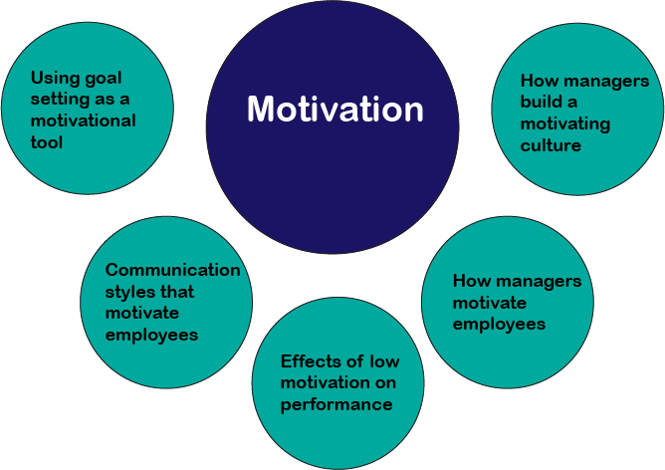
Now, imagine that you are looking for articles related to leadership. Create a diagram like the one above.
Main Organizational Behaviour Concept: Leadership
Related ideas/subtopics:

Now, with your group members, brainstorm search terms for all three of the challenge areas that you have identified. When you have finished this, you will be prepared to conduct your research.

Chapter 8

Task 4: Conducting Your Research

Andre Iwanchuk

Learning Objectives
By the time you complete this task, you will be able to
- Use business databases to find relevant articles for your report
- Access additional help from a business librarian

Conducting Basic Library Searches
There are many ways to find information on a topic. The library homepage provides access to Summon Search, the Library Catalogue, Research Databases, KORA, and Journal Titles.
- SUMMON SEARCH: “everything”
Searches just about everything Kwantlen library has to offer – books, articles, and more. This is a great place to start your research.
- CATALOGUE: books, e-books and multi-media only
Searches the Library’s book and multimedia collection – books, e-books, online videos, DVDs.
- RESEARCH DATABASES: individual databases
Provides a list of all the databases to which Kwantlen subscribes. Research databases provide access to journal citations and full text articles.
- JOURNAL TITLES: Determines if full text access to a journal is available.
This is particularly useful if you have a list of journal articles you want to find.

RESEARCH DATABASES:
Business Source Complete: Comprehensive full text academic and popular articles for all disciplines of business. Also includes access to items such as company profiles, country reports and industry information
Canadian Business & Current Affairs (CBCA) Complete: Full text access to current events and academic information as produced in Canada.
Canadian Newsstream: Full text access to Canadian national and leading regional newspapers.
Academic Search Complete: Interdisciplinary full text database of academic and popular journals covering an extremely wide and deep selection of subjects, topics and article types.
IBISWorld: U.S. and Canadian market research industry reports.

RESEARCH DATABASE SEARCH TIPS:
- Think of concepts and synonyms and use these to generate keywords
- Come up with synonyms and broader/narrower/related terms
- Cycle your search – use your first search results to help focus your next searches
- Find additional articles by looking at subject terms, references, citing articles, authors, and journals
- Use AND, OR, “quotation marks” and the wildcard symbol * to return more relevant search results
  - AND – combine concepts (workplace AND communication)
  - OR – includes synonyms and related words (workplace OR employee)
  - “quotation marks” – use when searching for a phrase (“workplace communication”)
  - Truncation * – use for terms with multiple endings (Canad* picks up Canada, Canada’s, Canadian, Canadians etc.)

Helpful KPU Library Resources
SUBJECT GUIDES: Librarians have created guides to useful resources covering a particular subject area. These guides are great for getting an overview of a subject area.
- Business Subject Guide–http://libguides.kpu.ca/busi
RESEARCH STRATEGIES:
http://www.kpu.ca/library/research_strategies
SCHOLARLY PUBLICATIONS (PEER-REVIEW) http://www.kpu.ca/library/databases/scholarly-publications
CITATIONS & PLAGIARISM: http://www.kpu.ca/library/citationsplagiarism
GOOGLE & GOOGLE SCHOLAR SEARCH TIPS:
Try these advanced search operators:
- intitle: (limits search to document title e.g. intitle:”workplace communication”)
- site: (restrict search to specific domain – site:edu, site:gov)
- filetype: (restrict search to a specific file type – filetype:pdf)
HELP:
- Andre Iwanchuk, Business Librarian – Andre.Iwanchuk@kpu.ca / 604.599.3486
- Ask A Librarian / AskAway service (IM with a Librarian) http://www.kpu.ca/library/services/askalibrarian

Chapter 9

Task 5: Take Notes from Research

Christina Page

Learning Objectives
By the time you have completed this task, you will be able to:
- Use paraphrasing strategies to avoid accidental plagiarism
- Extract key information from articles that you will use to prepare research summaries
Integrating Material from Research
One of the main tasks in academic research is to incorporate material from other sources and to discuss this material in light of the argument you are making. One popular book on academic writing uses the phrases “They Say/I Say” in its title (Graff, Birkenstein & Dunst, 2012); this is an excellent way to describe this process.
They Say | I Say
-Information that you learned from your research and reading (either a quote, paraphrase, or summary). | -Your discussion of this information, related to how it supports the key points in your paragraph, and how it supports your thesis.
Quote, Paraphrase, Summarize – What’s the Difference?
- Direct quote: This uses information word for word from your original source. Short quotations must be in “quotation marks”, while longer quotations are indented (search for information on block quotations for details)
- Paraphrase: Ideas from another source are written in your own words. It is NOT enough just to change a few words. You must rewrite the idea in your own sentence or paragraph. All paraphrases must include in in-text citation after the information.
- Summary: A much shorter presentation of the information you have read – for example, a sentence that describes the information in an entire chapter or research article.
All of the above require an in-text citation after the information is presented.
How to Paraphrase
Writing an original paraphrase takes work! The following steps can help you avoid accidental plagiarism when paraphrasing.
- Read the text 2 or more times, until you are sure that you understand it well. Take the time to look up words that you do not understand.
- Close the book or put the article aside. Say the meaning of what you have just read out loud.
- Based on the information you said aloud, write down your paraphrase.
- Check the paraphrase against the book or article to make sure that key details are correct.

Paraphrase Practice:
Consider the following paragraph:
Self-testing is one of the most powerful study strategies. Creating good questions requires you to think critically about what you need to learn (planning). Testing whether you can answer questions without referring to a text or notes, as you would in an exam, allows you to effectively monitor your progress. The trick to effective self-testing is to ask the right questions. In university, you are required to move beyond recalling basic facts and details, and must learn to apply and analyze material deeply (Kwantlen Polytechnic University Learning Centres, 2018, p.63).

In this exercise, you will follow the four step method described above to create a paraphrase of this paragraph.
- Read the paragraph at least two times, making sure you understand it thoroughly.

- Look away from the exercise and say your paraphrase out loud.

- Now, without looking at the original information, write your original paraphrase on a separate sheet of paper.

- Check to see that your paraphrase is accurate.
As you take notes from articles to prepare your research summary, take the time to paraphrase, rather than copying quotations. This will help you to understand the article more clearly, and will help you avoid accidental plagiarism when it comes time to write.
Consider the following template for notetaking. The template can be downloaded here.

Chapter 10

Task 6: Write Your Research Summaries

Christina Page and Lesley McCannell

Learning Objectives
By the end of this task, you will be able to:
- Integrate information from external sources and course material
- Use your research notes to create a research summary
Integrate information from external sources and course material
Now that you have found your articles, you will need to apply a reading and note-taking strategy in order to create effective research summaries.
- Read the abstract first. The abstract is the summary at the beginning of the article. Check to see that it is relevant to your topic. If the abstract is not helpful, it is unlikely that the article will be useful to you. Move on to another article to avoid wasting time, and to find the best possible articles for your research summaries.
- Read the whole article for understanding. Skim where needed in order to understand the main points. AVOID selecting quotations out of context. You may wish to read with a partner. After reading, identify:
  - What are the key points in this article? Write these down, or type these into a file on your computer. Highlighting or underlining is not enough, and can lead to accidental plagiarism. Write all of the key points in your own words. This will help you later when you write your research summary and integrate research into your paper.
  - How does this information relate to the case study?

- Write the research summary that includes:
  - Your summary of the information in the resource
  - Your description of how this will contribute to your deliverable.

Example Research Summary
Cooper, S.E., Nieberding, A.O, & Wanek, R. (2013). Successfully restructuring an executive leadership team: A case study in change management. Consulting Psychology Journal: Practice and Research, Vol. 65 (2), June, 2013. pp. 164-175. Retrieved from http://dx.doi.org.ezproxy.kpu.ca:2080/10.1037/a0033610
The first article describes a case study involving the executive leadership team during a period of change in the organization when roles and responsibilities at the top of the organization were restructured. An interesting feature of this article is that it includes a case study and the Chief Executive Officer’s first perspective about how change was implemented based on the recommendation and guidance of two consultants with varying perspectives. The consultants worked closely with the leadership team and involved the application of two organizational consultation methods: Schein’s process consultation and a change management framework.
The article describes Schein (1998) Process Consultation as “the creation of a relationship that permits the client to perceive, understand, and act on process events that occur in the client’s internal environment in order to improve the situation as defined by the client” (Schein, 1998, p. 20) and the change management framework.
The change management framework was applied to address resistance to change in organizational settings. The key elements of managing resistance to change may include alterations in (a) strategy, (b) structure, (c) work design, (d) human resources (HR) practices, and (e) management and informational systems (Cummings & Worley, 2009). A key to the consultative process was that an organic rather than a mechanistic design was attempted in an effort to help the organization have a strategy that was innovative, a structure that was flat, lean, and flexible; work design that included enriched jobs and self-managed teams; human resources involvement in selecting and supporting good talent; and management and information systems with high employee involvement, as well as open, inclusive, and distributed information (Cummings & Worley, 2009).
The articles goes on to present the case study from the framework of the generic four stages of consultation – entry, diagnosis, implementation, and disengagement. The framework provided a common view for the consultants and the CEO. Each stage was defined, the process of choosing and applying the organizational consultation methods were discussed, and the outcomes identified.
Finally, the article provides the CEO’s first person perspective and lessons learned that include seven themes that emerged as a result of the consultative process, guidance, and recommendations related to organizational change and restructuring. The first theme was the importance of taking the time needed to create a clear consultation contract. The second theme was the importance of obtaining and maintaining support for the goals and processes of the consultation from those with power in the organization, the CEO in this case. The third theme was the importance of obtaining buy-in from all the clients (stakeholders) involved in the project. The fourth lesson learned was the need for the consultations to develop deep trust with the key client groups – the executive cabinet and the larger leadership team. The fifth key factor was the willingness to change the consultation focus as priorities and situational consulting needs shifted. The sixth element to the success was to find consultants that both fit the knowledge and skills required by the consultation and where the work styles of the two consultants blend in a productive manner. Lastly, the final lesson learned was the deliberate inclusion of reflective practices before, during, and after each consultation.
An interactive or media element has been excluded from this version of the text. You can view it online here:
https://kpu.pressbooks.pub/obprojectworkbook/?p=44

Chapter 11

Task 7: Develop Recommendations for Challenge Area 1

Christina Page and Lesley McCannell

Learning Objectives
By the time you complete this section, you will be able to:
- Analyze an example recommendation to determine the characteristics of a recommendation that meets assignment criteria
- Develop an outline for your first recommendation along with your group members
Analyze an Example Recommendation
In the exercise below, you will review an example recommendation to identify why it is well-written, and how it meets assignment criteria.
First, review the overall structure of the recommendation. Download a worksheet to use with your group.
Consider the following questions as you reflect:
- How many research sources did the author of this recommendation include?
- How is the research integrated into the recommendation?
- How did the writer of this recommendation use an appendix to support their work?
- Based on what you have observed, what must you include in each section to produce a successful recommendation?

Recommendation Example:
Recommendation Content | Notes about what is included in this section
What to do:
Why do it:
How to do it:

An interactive or media element has been excluded from this version of the text. You can view it online here:
https://kpu.pressbooks.pub/obprojectworkbook/?p=46
Evaluate the recommendation above according to your rubric criteria. Download the worksheet and complete it with your group.
Rubric criteria | Indicators | Grade /5 | Rationale (why did you assign this grade?)
Comprehensive recommendations are supported by analysis and research
Recommendations clearly state what to do and why. Detailed action plan provided

Chapter 12

Task 8: Develop Recommendations for Challenges 2-3

Christina Page

Learning Objectives
By the time you complete this section, you will have
- Used instructor feedback to edit your first recommendation and to identify strategies for writing the next two recommendations effectively
- Drafted the remaining recommendations in your report
“We all need people who will give us feedback. That’s how we improve.” – Bill Gates
During the learning process, we have many opportunities to receive feedback about the quality of our learning and work. Considering and acting on this feedback is a step in creating the most effective report possible. Before you continue drafting your remaining recommendations, you will consider your initial feedback, make changes to improve your report, and plan to implement this feedback as you write the remaining sections of the report.
Questions for reflection: After you have received feedback on your first recommendation, discuss the questions below in your next group meeting.
- What grade do we hope to achieve on this assignment? ________
- To what extent are we on track for meeting this goal?
- What about our first recommendation was effective?
- What does the feedback about our first recommendation indicate we should change?
- How will this feedback be helpful as we complete the assignment?
At the end of your discussion, complete a chart like the one below. Based on your feedback, what should you stop doing? What do you need to start doing in order to be effective in this assignment? What should you continue to do (these are things that are already effective in your report that you want to carry forward through the rest of the assignment).

Use Evaluation to Support Planning
Stop
Start
Continue

Next Steps: Edit and Continue Drafting Recommendations
Now that you have considered your feedback, you have two tasks to complete.
- Use the feedback to improve your first recommendation by editing.
- Write your next two recommendations implementing your key learnings from this exercise.

Chapter 13

Task 9: Draft Your Report

Chapter 14

Task 10: Format and Polish Your Report

Christina Page

Learning Objectives
By the time you complete this chapter, you will be able to
- Follow a systematic editing process to revise your first draft
- Format your business report using appropriate conventions
- Access additional support for revising your work
Editing Your Report
You’ve completed your first draft. Congratulations! But are you really finished your assignment?
Editing is an important step in creating a polished and professional report. Knowing how to edit your work and format it effectively is a key skill for your professional practice.
Complete this video quiz to learn about a systematic process for editing your work.
An interactive or media element has been excluded from this version of the text. You can view it online here:
https://kpu.pressbooks.pub/obprojectworkbook/?p=52
As you heard in the video quiz, proofreading is another key step in polishing your paper. If you want to learn more about how to proofread effectively, watch this video.
Following Formatting Conventions
As a business student, you are working to develop your professional writing skills. Part of this is learning to follow the conventions for formatting business reports. Your assignment instructions give guidelines for how your report is to be presented. Complete the quiz below to test your knowledge of these guidelines.
An interactive or media element has been excluded from this version of the text. You can view it online here:
https://kpu.pressbooks.pub/obprojectworkbook/?p=52
Accessing Support
The Learning Centre offers writing tutoring in a variety of formats: face to face and online. Because this is a group project, at least two members of your group should be actively involved in tutoring visits. You can book appointments at tlc.kpu.ca. Tip: Book an appointment early to be sure you have your preferred time slot. Appointments can fill up quickly.
If you need assistance booking an appointment, the video below demonstrates the steps.
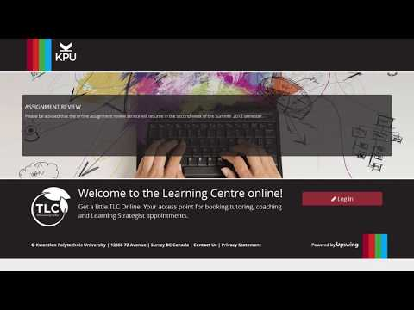
A YouTube element has been excluded from this version of the text. You can view it online here: https://kpu.pressbooks.pub/obprojectworkbook/?p=52

1

Appendix
This is where you can add appendices or other back matter.

Graff, G., Birkenstein, C., & Durst, R. K. (2012). “They say/I say”: the moves that matter in academic writing: with readings (2nd ed). New York: W.W. Norton & Co.
Kwantlen Polytechnic University Learning Centres. (2018). University 101: Study, Strategize, Succeed. (C. Page, Ed.). Surrey: Kwantlen Polytechnic University. Retrieved from https://pressbooks.bccampus.ca/studystrategizesucceed/
McMaster University (2009) Three Column Note taking. http://www.mcmaster.ca/academicintegrity/students/typeofad/plagiarism/3ColmNote.html

