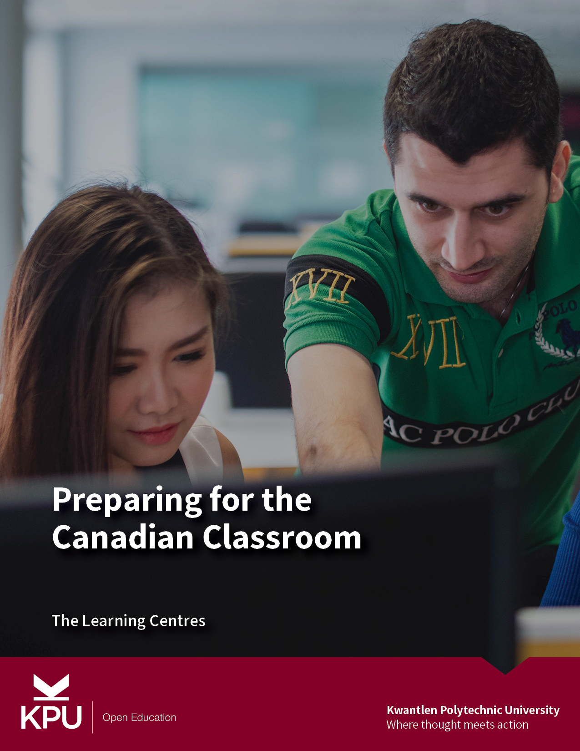

Preparing for the Canadian Classroom

Preparing for the Canadian Classroom

Kwantlen Polytechnic University Learning Centres

Kwantlen Polytechnic University

Surrey, BC

Preparing for the Canadian Classroom by Kwantlen Polytechnic University is licensed under a Creative Commons Attribution-ShareAlike 4.0 International License, except where otherwise noted.

Contents
- Introduction
- Set expectations for the Canadian classroom
- Build relationships with instructors
- Develop active learning strategies
- Manage time for independent learning
- Read with a purpose
- Develop your technical skills
- Prepare for the journey ahead
- References


Welcome to KPU! You’re about to begin a learning journey that will challenge you as you develop intellectual, interpersonal, and practical skills that will support you in your future career.
Choosing to study internationally also means that you are beginning an intercultural learning journey. Your personal strengths and prior learning will support you along this path. You will also quickly notice that ways of learning might be different in Canada than you’ve experienced before, while other aspects of your life as a student may be quite similar.
This resource is designed to help you start your journey well. This book will introduce you to key skills that you can begin developing even before you travel to Canada.
Let’s begin!
How to Navigate this Book
To move to the next chapter of the book, look for the next arrows on each page of the site.

Chapter 1

Set expectations for the Canadian classroom

Learning Objectives
By the time you finish this chapter, you will be able to
- Describe the information you will find on a course outline/course presentation
- Define continuous assessment and explain how it affects you as a student
- Explore how a typical Canadian university class might be organized
Understand Your Course Presentation
On the first day of every KPU class, you will receive a document called a course presentation. It is prepared by your instructor, and it is like a “map” for the learning journey ahead. A course presentation explains:
- Course LearningObjectives: Learning Objectives describe the knowledge and skills that you can expect to gain in the course.
- Assignments and Exams: Your learning in a course may be measured through individual or group written assignments, oral presentations, exams, reflection activities, and course participation, among other things. The course presentation will tell you how much each assessment is worth, and when the assessment will take place (ie. when the assignment is due or when tests will be given).
- Tentative Schedule of Topics: This typically includes a list of readings and discussion topics for each week of the course. Use this schedule to organize your weekly reading.
- Policies: This section of the course presentation includes Kwantlen Polytechnic University policies regarding class conduct, evaluation, testing, late assignments, and plagiarism are observed for all courses. Everyone at KPU must comply with the policies laid out.

Assessment at Canadian Universities
In the Canadian university system, you will usually be evaluated with continuous assessment. This means that assignments, projects, tests, and exams will be given throughout the semester. Usually, the final exam in the course is worth no more than 30% of the total course grade. This means that it is important to start off the semester on the right track, as your final grade begins to develop right from the beginning of the course. Be sure to take note of all assignments, and make a plan to complete them on schedule.
The Canadian Classroom
In many courses, instructors will use methods that are student-centred, and that use active learning. This means that you should expect to work in groups with your classmates, and contribute your ideas by actively participating. The structure of the Canadian classroom often means that you will not find all of the needed information by reading the textbook alone, and that making class attendance a priority is crucial to your success. Participation in a university class may include:
- Completing reading assignments before class so that you are able to contribute to class discussions.
- Discussing answers to questions in class with a small group of fellow students, or participating in a discussion circle.
- Actively listening and writing down important ideas.
- Working with classmates to complete an in-class activity assigned by your instructor.
- Completing formal or informal quizzes.
- Posting responses to questions on an online forum.
- Completing problem sets from your textbook or online.
At KPU, you can expect to be in a class of 35 students or fewer, and you can expect to get to know your instructor and classmates.
In the chapters that follow, you will learn more about how to how to develop a good relationship with your instructor, and how to use active and independent learning methods that support the structure of Canadian university classes.
An interactive H5P element has been excluded from this version of the text. You can view it online here:
https://kpu.pressbooks.pub/canadianclassroom/?p=5#h5p-1

Chapter 2

Build relationships with instructors

Learning Objectives
By the time you finish this chapter, you will be able to:
- Describe instructor-student relationships in the Canadian university context
- Plan to use instructor office hours to support your learning
At KPU, you will be in small classes where you are able to develop a relationship with your instructors. Often, students find it intimidating to relate to their instructors. This may be especially true when you are unsure of the right way to communicate with instructors in a Canadian university context.
Though no two instructors are the same, most instructors will have the following expectations:
- Instructors expect university students to be responsible for their learning. This means that students are expected to be prepared for each class, and to take responsibility for completing coursework and assignments on time. Class preparation may include tasks like completing assigned readings and pre-class quizzes. Your course presentation and/or Moodle site may list the tasks you are expected to complete before attending each week’s class.
- Instructors expect university students to take initiative and they want to help their students be successful. This means that most instructors want their students to come and talk to them when they need extra help – or just to get to know the instructor better.
Using Instructor Office Hours Effectively
Instructors hold office hours each week. This is the time that they set aside for students to come and talk to them. These office hours are listed on the course presentation. In office hours, you may wish to:

  - Ask a question about the course presentation or the course assignments.
  - Ask a question about something that was not clear to you in class time.
  - Ask for tips on how you can be successful in the course.
  - Ask other questions about the subject area, even if they are not related directly to the course.
If you are not able to attend office hours (perhaps because you have another class scheduled at that time), you can e-mail the instructor to schedule an alternative time to meet. Your instructors want to help you succeed, and they appreciate when students come to meet with them.
Take time to attend office hours early in the course and get to know your instructor. The more your instructor knows you, the better they are able to support you in the course. Instructors that you know well are often able to provide references for you, and to help you connect to other academic, volunteer, and professional opportunities.
An interactive H5P element has been excluded from this version of the text. You can view it online here:
https://kpu.pressbooks.pub/canadianclassroom/?p=22#h5p-2

Chapter 3

Develop active learning strategies

Learning Objectives
By the time you have finished this chapter, you will be able to:
- List ways you can incorporate active learning into your study strategies
- Describe the role of independent learning in university courses

One major concept in the Canadian education system is that courses may use a wide variety of active learning activities — both in and outside of the classroom. This is particularly true in post-secondary education. Your learning may involve listening, reading, taking notes, and writing. It also may involve group discussions, presentations, simulations, creating diagrams or posters, and solving problems. Active learning strengthens your understanding of course content by allowing you to approach it in different ways, critically think about what you are learning, and develop strong skills for communicating with others.
Making Active Learning Work for You
The four broad categories of learning strategies that you may encounter in an active learning classroom are: individual activities; paired activities; informal small groups; and cooperative student projects. When you are engaging in an active learning activity, you may want to think about the following questions:
- What Learning Objective does this learning activity help me to achieve?
- Do I need to prepare for an upcoming activity outside of class (for example, by pre-reading?). How will I do this?
- How much time do I have for this activity? How should I organize this time?
- Is this an individual, pair, or small group activity? If I am working in a pair or group, how will we organize ourselves to work effectively?
- Will I submit this activity to my instructor during or after class? Is this activity part of a larger project that I will submit later?
Choosing to participate as fully as possible in the active learning process allows you to get the most benefit from attending class. This is one of the reasons why regular class attendance is an important part of successful learning at KPU.
Independent Study
Most KPU course meet for 3 hours weekly, often only once a week. However, it is important to know that you are expected to put in significant independent study time for each course; typically, you should spend 2-3 hours of independent study time for each hour of time you spend in class. This means that, on average, one university course requires 9-12 hours of your time each week.
What do you do with this time? One of the differences you may notice is that instructors give less direction about what they would like you to do week to week. The responsibility for meeting the Learning Objectives of the course is up to you. For many courses, your independent study time might include:
- Reading all required and recommended course readings (ideally, before attending class).
- Writing notes on your reading.
- Reviewing your notes and self-testing. Use active learning techniques here rather than simple re-reading. Discuss material in a study group, use flash cards, create charts and diagrams, and actively quiz yourself.
- Preparing for tests and exams.
- Completing assignments.
In the next chapter, you will learn more about how to manage your time for effective independent learning.
An interactive H5P element has been excluded from this version of the text. You can view it online here:
https://kpu.pressbooks.pub/canadianclassroom/?p=24#h5p-3

Chapter 4

Manage time for independent learning

Learning Objectives
By the time you finish this chapter, you will be able to:
- Understand how to allocate time for your courses to contribute to your success.
- Describe how semester and weekly schedules can help you manage time.
Many international students have busy lives. This is especially true if you plan on working or volunteering while you study. How can you balance multiple commitments successfully?
First, it is important to remember your long-term goals, and prioritize your studies. After all, your main job — and the one that supports your long-term success — is being a student. If you are taking three courses, this means scheduling between 27-35 hours for weekly study. If you are taking more than three courses, you will need additional study time. How can you be sure that you can balance your commitments effectively, while maintaining a healthy lifestyle?
Use Schedules for Planning
Semester Schedules
A semester schedule gives you a visual picture of the assignments, projects, tests, exams, and field trips that will happen during the semester. If you are taking a number of classes, this is a tool to be able to see what is coming up next.
A semester schedule includes important assignments, tests, exams, and other key events that will happen in your life during the next months. You may wish to use colour to indicate different classes, or to distinguish between your academic events and personal events.
Look at the example semester schedule below. What do you notice about what the student chose to include? What will you include on your semester schedule?

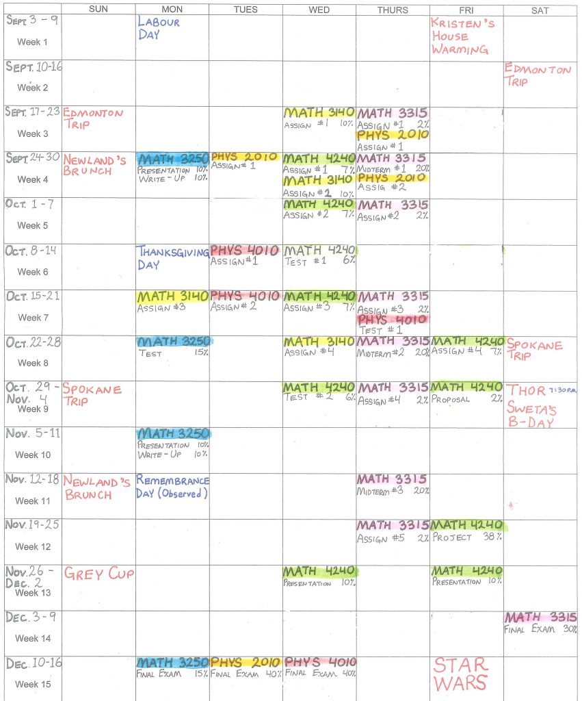

Weekly Schedules
Your next step is to create a weekly schedule. This will include your class times and any regularly schedule commitments. A weekly schedule is a good tool to evaluate whether your time use allows you to meet your overall goals. Do you have enough time for study? Is there time to maintain a healthy lifestyle?
The following principles will guide you as you create your weekly schedule:
- Record class and lab times in appropriate day/hour blocks on a time schedule sheet.
- Record travel times to and from the university and between classes.
- Record meal times, family times, laundry times, etc.
- Record all regularly scheduled personal activities such as meetings, employment and athletics.
- Record any special activities you need to do or want to do on a regular basis.
- Schedule a preview time (30 minutes) immediately before each class whenever possible. During the preview, review all or some of your notes in preparation for the upcoming class. If you have two or three classes in a row, preview from last to first class.
- Schedule a review time immediately after your classes (30 minutes) whenever possible. Use this time to edit and summarize your notes. You can also look over any assignments that were given and begin to plan when and how you will do them.
- Schedule intensive pre-reading / study / review time for each class. Try to schedule some study time each day for each class. Learning is more effectively and efficiently accomplished in shorter regular sessions than in longer irregular sessions. Also, use more of the day (i.e. morning, afternoon) for studying. Pick the times of days when you are most alert.
- Schedule to start your study period with the courses you like least or that you’re not doing well in. Try to study the same subjects at the same time each study day. Although this seems to be a mechanical way of scheduling, you will find that such a routine can help you develop a pattern for efficient and effective learning.
- Schedule a weekly review (WR) for each course. Do it at the end of the week if possible. This weekly review gives you an opportunity to go over the past week’s notes along with the reading assignments to see what you have been learning in the past week during class and study time for each course. You can also look ahead to plan the next week and determine how much reading you need to do, what projects are due, and if any tests are scheduled.
- Keep open some time for daily physical activity. Remember, research indicates that regular exercise will not only give you a general sense of well-being, but can reduce tension and help you accomplish a tough class, study, and work schedule.
- Label some empty blocks of time as OPEN for academic or personal needs.
- Schedule some time during Friday, Saturday, and Sunday for you to play, relax, or do whatever you want to do. This is your reward for sticking to your schedule. In addition, you’ll enjoy your free time more. Because it is scheduled you do not need to feel guilty.
Here is an example of what a completed weekly schedule might look like:
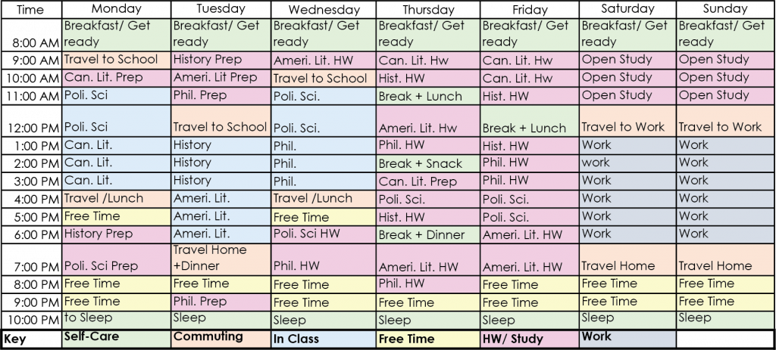
When to Create Schedules
Creating semester and weekly schedules is best done at the first week of each semester. You will be able to pick up a paper copy of these tools at any KPU Learning Centre. You can also download semester and weekly schedules from the links below.
- Semester Schedule Planner
- Semester Schedule Planner (11×17)
- Weekly Schedule Planner
- Weekly Schedule Planner (11×17)
An interactive H5P element has been excluded from this version of the text. You can view it online here:
https://kpu.pressbooks.pub/canadianclassroom/?p=26#h5p-4

Chapter 5

Read with a purpose

Learning Objectives
By the time you finish this chapter, you will be able to:
- Explain the types of reading that are typical in Canadian university courses
- Use the SQ3R strategy to read purposefully
Canadian university courses typically require a significant amount of reading. This may include textbooks, academic articles, and other online material assigned by your instructor. You may be assigned reading from regular books, or from material that is only available online. How can you manage your reading effectively?
When you approach a textbook or other course reading, you are using it as a tool to learn the material that you need to know for your course. To achieve your aims, you will want to read with a purpose. One method for reading purposefully is called SQ3R. The acronym SQ3R reminds you of the elements of this reading method – Survey, Question, Read, Recite, Review – that will help you become a more effective reader.



Survey
- Survey the title: Think about what you may already know about that topic.
- Survey the introduction: It gives you an idea about how the chapter is organized, and what you will be learning. If your chapter includes a list of Learning Objectives, you will want to pay particular attention to these. The Learning Objectives outline the key concept you will want to master as a result of your reading.
- Survey anything in bold: Subtitles are labels. Other bolded items may be definitions that you will need to know.
- Survey the pictures, charts and graphs: Glance at these to pick out things that seem interesting or informative.
- Survey the summary at the end: This will review and give you the key points in the chapter.
- Survey the questions at the end of the chapter: These will help focus your attention on the main points.
- Survey your course syllabus/course presentation and see what topics the Instructor is focusing on.
Question
When you have completed your survey, you will begin reading, focusing especially on items that you identified as important when you survey. Write “Who, What, Where, When, Why, and How” questions for each subtitle or definition (you can do this as you progress through the reading). These questions will become the headings in your notes.
Read
Read to answer the questions you have created. Once you have found the key information needed, move to the next step.
Recite
- Recite the answer to your question out loud. Do this as if you are explaining to a study partner.
- After reciting, write this information down.
- Repeat this step for each question that you created.
Review
- Stand back and look at the chapter as a whole.
- How do the ideas and facts you learned from each subsection fit together?
- Review your notes to be sure they make sense to you.
An interactive H5P element has been excluded from this version of the text. You can view it online here:
https://kpu.pressbooks.pub/canadianclassroom/?p=28#h5p-5
Additional Learning
Watch the video below to see how the SQ3R method applied to the style of textbook you will often find in a KPU course.

A YouTube element has been excluded from this version of the text. You can view it online here: https://kpu.pressbooks.pub/canadianclassroom/?p=28

Robinson, F.P. (1978).
(6th ed.). New York: Harper & Row.

Chapter 6

Develop your technical skills

Learning Objectives
By the time you finish this chapter, you will be able to:
- Identify the computer skills that will support your success as a KPU student
- Plan to develop your skills before you begin your study program
KPU aims to support students in developing 21st Century Skills. This means that most of your classes will require you use information technology to complete your course work and assignments. You will usually be required to submit typed, rather than handwritten, assignments. Common required skills include:
- Touch-typing (typing quickly and efficiently on a computer keyboard).
- Formatting documents in Microsoft Word, Excel, and Powerpoint.
- Creating blog posts and electronic portfolios using online software.
- Making notes on online documents.
- Using email to contact instructors and other KPU professionals.
You will find your transition to KPU easier if you are able to acquire some of these skills before you arrive. You will also want to decide if you want to purchase a laptop or tablet/keyboard. Computers are available for you to use on campus, but many students find it easier to manage their time if they are able to work on a personal device at home. KPU students have free access to Word, Excel, and Powerpoint on your own personal device, so there is no need to purchase this software.
How to Learn
There are many free online tutorials to help you develop your skills with information technology. Below you will find a few places to start.
- Typing Skills: typing.com
- Free Microsoft Office Tutorial from GCF Global
Getting Connected
Once you are a KPU student, KPU will communicate with you via your KPU email address. Be sure to log in and begin using this address as soon as you receive it. You will receive important information from the university and from your instructors at this address.
Each one of your courses will also have a course website that uses software called Moodle. You will find your course websites by logging into courses.kpu.ca. It is important to do this before classes start and in the first week of the semester so that you don’t miss important information about your course.
An interactive H5P element has been excluded from this version of the text. You can view it online here:
https://kpu.pressbooks.pub/canadianclassroom/?p=30#h5p-6

Chapter 7

Prepare for the journey ahead

Now that you’ve completed these chapters, you have an idea of what to expect and how to prepare for success at KPU. You may feel that you have many new and challenging experiences ahead of you. At KPU, you will have a team of people to help you at each step along the way.
The Learning Centres at KPU help you learn how to learn effectively in any KPU course. At the Learning Centres you will find highly trained peer tutors to support you in your courses, workshops to help you develop learning skills, and 1:1 consultations with Learning Strategists to support you in developing a personalized learning strategy. All of these services are free to you as a KPU student.
To find out more, visit the Learning Centres website.
If you wish to read more about learning in the Canadian university, you can read our free online book: University 101: Study, Strategize, and Succeed.
You can also visit the KPU Learning Centres Youtube channel for short videos on how to learn in a Canadian university environment.

1

References
Kwantlen Polytechnic University Learning Centres. (2018). University 101: Study, strategize, succeed (C. Page, Ed.). Kwantlen Polytechnic University. https://pressbooks.bccampus.ca/studystrategizesucceed/
Macpherson, A. (n.d.). Active Learning. Kwantlen Polytechnic University. https://www.kpu.ca/sites/default/files/Learning%20Centres/Study_ActiveLearning_LA_0.pdf

