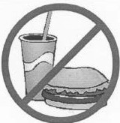

NO FOOD OR DRINK

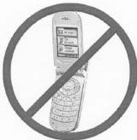

NO CELLPHONES

By signing this document I acknowledge that I have read and understood that no food and drink or cell phones are allowed in the lab. I understand that these items may be confiscated.

Name Signed Date