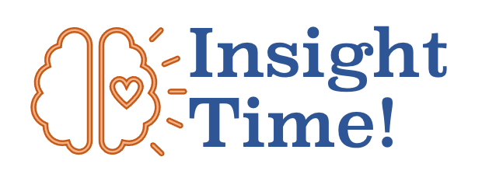
Part 5: Bodies and Health

My Insights on Bodies and Health

You’ve made it to the end of this section! You’ve accomplished a lot! Let’s take some time to collect your thoughts. An “insight” is an understanding that has a depth to it; it is an idea that has been dug up by you with effort and struggle. An insight is an achievement! This workbook is designed to help you make your own insights. What insights did you make so far?

The Biggest Insight I developed in this section:

What I want to think more about:

I learned this stuff in my lectures, discussions, and readings that was not in this workbook so far, but feels important to me too:

Things I disagreed with or had different ideas about in this section:

