Part 5: Health

Social Determinants of Health
Loop it! Choose one social determinant of health and fill in the loop. How do various factors work together to affect health? For example, see poverty:
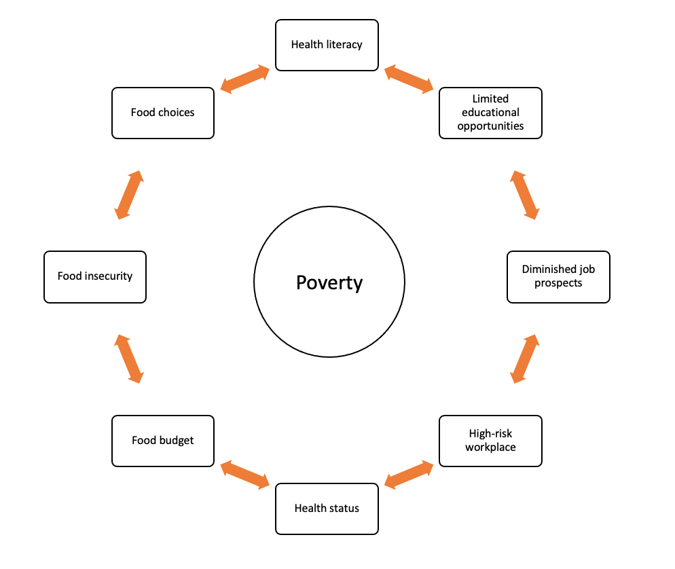

Your turn:

