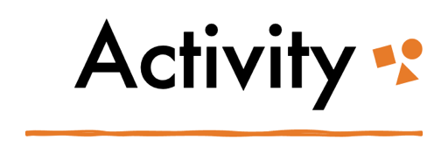
Part 2: Institutions

Institutions and Representation
Part 1: Mix up! Unscramble the words related to institutions and oppression.
- ESIXTS (hint: discrimination based on sex): _____________________________
- NIYROIMIDCTRAS (hint: biased): _______________________________________
- NTJUUS (hint: not fair): _________________________________________________
- TTEEENNRRPSAIO (hint: depiction or proportion): ______________________

Part 2: Map it! Create a mind map representing the ways media and education are interrelated institutions as sites of institutionalized oppressions. A mind map is a non-linear diagram that represents complex relationships between concepts, words, ideas, etc., in a visual manner. Can you use the mind map to identify commonalities in these two institutions?

