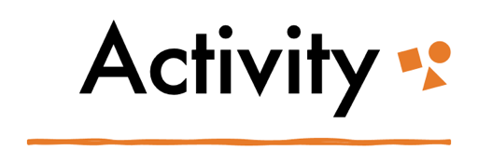
Part 2: Institutions

Institutions and Disability

Fill it Out! Jot down locations you frequent using the space below. Include at least one social institution, community space, commercial space or business, and a private space (like a home).

If you identify as able-bodied/neurotypical: try to imagine you are a person with physical, mental, or sensory disabilities accessing these spaces. How might your experiences accessing services and navigating institutions differ from your current lived reality?

If you are disabled/neurodivergent: jot down any experiences you have had with the three locations where your accessibility needs were not met.

Then, reflect on what specifically needs to change in order for those environments to be more accessible?

 | Social institution | Community space | Commercial space or business | Private space
Physical barriers
Environmental barriers (e.g., sound, lighting)
Communication barriers (e.g., information displays)
What needs to change?

