Preparing to Work in a Diverse Team

Learning Objectives:
By the end of this lesson, students will:
- Identify the (cultural) identities that have most shaped them
- Describe their own values related to communication, leadership, time, and planning
- Discuss the ways in which their values differ from those of others
- Use a team charter to articulate their team culture
- Practice suspending judgment using the DAE framework

Part 1: Cultural Identities and Values

Connection: What’s Your Identity?
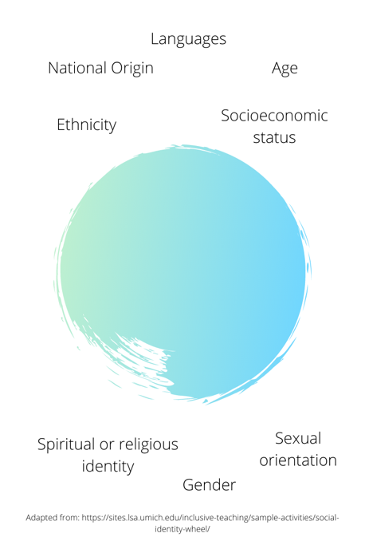
Every one of us brings a unique social identity, which is a blend of our personal characteristics, the groups to which we belong, and our experiences. This image presents a few of the dimensions that can shape our identity.

Choose some or all of the categories in this diagram, and make a note of what shapes your identity. Which of these areas are most important to you in understanding who you are?

When we work with others, particularly those with different identities than our own, it is important to understand ourselves – what shapes us – and how this impacts who we choose to be in the world. Later in class, we’ll explore how our identities and experiences shape our values and the ways in which we prefer to work with others.
Content: Weird, or just different
By default, we see the world through the perspective of our identities. When we see or experience something that is different from our expectations, we may perceive it as “weird” or “wrong”.

Video: https://www.ted.com/talks/derek_sivers_weird_or_just_different/transcript?language=en

With a partner, share:
- Three things you noticed in the video
- Two comments
- One question you have after viewing the video

The video highlights the assumptions that we make about what is “correct” or “normal”. We often have similar assumptions that are based on our values. These assumptions are often difficult to uncover, because they are based on what we perceive as “normal” or “right”. Sometimes, these values are described as dimensions that vary according to culture, or where a person is from. There is some truth to this idea, but it is also somewhat incorrect, because it can cause us to make assumptions about what someone values based on where they are from. This can lead to stereotypes that can be harmful. Often, people who come from the same area share similar values and assumptions because they share similar life experiences. However, we are all individuals, and as we saw at the beginning when we reflected on our own identities, we are shaped by many factors besides the country we are from.

With this information in mind, we’ll explore a few of the value dimensions where people commonly have different beliefs and assumptions.

Values about Communication
It is best to share your ideas directly and clearly. |  | It is important to pay attention to the whole context of the communication to grasp the meaning.
The speaker/writer is responsible to make sure that the audience understands the meaning. |  | The audience is responsible for the work of understanding a writer’s/speaker’s meaning.
It is important to think critically and come to your own conclusions. |  | It is important to learn from respected experts, and to highlight their ideas above your own.
Values about Leadership
Having formal leadership in a team is not important. |  | It is important to have a formal leader for a team to work well.
All people on a team, regardless of age, role, or experience, should have equal voice and input. |  | It is important to listen to and respect those who are older or who have more experience on the team.
Values about Time
Respecting people’s time is important. Meetings should always start on time, and focus on the task |  | Relationships are more important than time. Meeting times and agendas should be flexible to people’s needs.
Values about Planning
A project should begin with a structured and clear plan. It is important that all tasks are completed according to the plan. |  | Flexibility is needed in project planning. The plan should shift according to the needs of the moment, as long as the task is completed well.

These values are on a continuum – we often find ourselves somewhere in the middle of both sides, and at other times, we find ourselves much closer to one value than the other.

Challenge:
Exercise: On the worksheet provided, plot your own values these areas on the continuum.

Pair Work: With a partner, share where you find your values on the continuum. Identify similarities and differences with your partner. What factors do you think account for these similarities and differences?

Change: 1 Minute Reflection
Write a one minute reflection that answers the following question:
“How does sharing my cultural values, and learning those of my teammates affect how we work together on a team?”

Part 2: Building a Team Culture

Connection: In the last session, we explored identities and values, some of which are culturally influenced. In this session, we will work through the process of developing a team culture.
In groups of 4-5, create a mind map that reflects what a “team culture” should include.
Content:
When we work in diverse teams, part of our process can include forming our own “small culture” or “team culture” that reflects how we will guide our relationships and our work together. It is important that the team culture reflects the values of all team members as much as possible, though compromise is sometimes needed because of our differences. As you form your team culture, consider how you will listen to the values, needs, and preferences of all team members.

One document that is often used to create a team culture is your team charter. The team charter outlines the strengths and skills of each team member, the roles they will take on, and the procedures that you will use in your work as a team. Your task for the next hour is to work with your teammates to create a team charter.
Challenge:
Develop a team charter
Links to templates:
- Team Charter Template (PDF | Word )
- Team Culture Development Exercise (for culturally diverse teams) (PDF | Word)

Change: 1 Minute Reflection
Write a one minute reflection in response to the following question:
“What aspects of our team culture will be most helpful in the success of our project?”

Part 3: Suspending Judgement and Managing Conflict

Connection:
Think of a time when you experienced a conflict when working with a team or group. What was your role in the conflict? What was the other person’s role? How did you resolve the conflict?
Brainstorm and share with a partner
Content:
Conflict is a normal part of life in a team. Success in a team doesn’t mean that you can avoid all conflict, but that you have a plan in place to resolve it and to continue to move forward. Tuckman’s (1965) model of group development proposes that teams move through four stages in their development: forming, storming, norming, and performing. When experiencing a team conflict, it may be helpful to consider the stage of team life that your team is currently experiencing, before deciding that conflict is making your team ineffective. For example, a team in the “storming” stage might experience conflict that is an expected part of developing roles and finding the best way to work together.

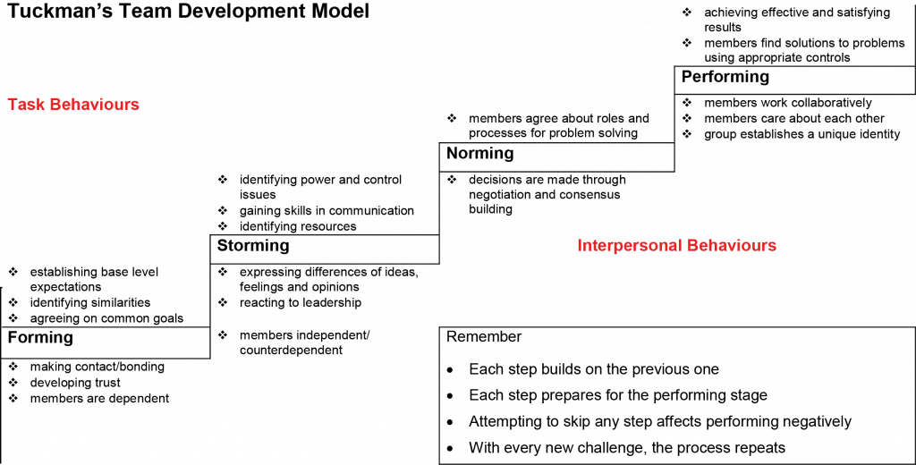

You may find it helpful, if you haven’t already, to add some team norms about how you will resolve conflict to your team charter.

Another reason for conflict arises from the assumptions that we make. This can be especially true when we are working with team members with different experiences and values from our own. When we communicate or experience someone else’s actions, we jump to assumptions about what they might mean. To reduce conflict arising from our assumptions, it is helpful to learn how to suspend judgement. The DAE technique, developed by Janet M. Bennett and Milton Bennett in the 1970s, is a tool for approaching situations more objectively.

The DAE technique moves through three steps:
- Describe – without any judgement – what is happening. Stay with the observable facts of the situation only.
- Analyze – generate a range of possible explanations for what you observe. Explore multiple possibilities, without attempting to select a “correct” explanation.
- Evaluate – Based on what you discover to be the best analysis (hint: ask questions!), determine what the appropriate step to take might be.

Challenge: Use the DAE technique to respond to ambiguous photos
(Instructor preparation: Select photos for students that can lead to multiple interpretations:
https://pixabay.com/photos/texting-mobile-phones-hands-two-1490691/
https://pixabay.com/photos/argument-conflict-controversy-238529/
https://pixabay.com/photos/nature-love-couple-in-love-grooms-1790142/
https://pixabay.com/photos/laptop-woman-education-study-young-3087585/

In groups of 2-3:
- Describe what is happening in the photo
- Analyze -- Generate as many possible explanations for what you see as possible
- Evaluate – What would each person in the scene be thinking/ feeling? What do I think/feel about what is happening in the image?
Debrief: In teamwork situations, you will use the DAE process to respond to others’ communication and actions. Let’s review one example.
Situation: Your teammate does not attend a scheduled group meeting.
Describe: Jo was absent for the team meeting. She had previously agreed to be at the meeting.
Analyze: What are the possibilities? (1) Jo is angry with the team members and chose not to be present (2) Jo forgot about the meeting (3) Jo lives in an area with limited internet, and was not able to join the meeting, even though she tried for almost an hour (4) Jo had a family emergency and was not able to contact the group
Evaluate: While I might quickly assume that (1) or (2) are true, making me angry with Jo, I will suspend judgement as I currently don’t know that (3) or (4) did not actually happen, and that Jo faced an unavoidable problem. I will contact Jo to find out how they are doing, and what prevented them from attending the meeting.

Change: 1 minute reflection
Write a one minute response to the following question: “How can using the DAE technique prevent or reduce conflict in an intercultural team?”

Worksheet: Values Exercise

Instructions: Mark an (x) on the line that represents where your values fall in each of these areas

Values about Communication
It is best to share your ideas directly and clearly. |  | It is important to pay attention to the whole context of the communication to grasp the meaning.
The speaker/writer is responsible to make sure that the audience understands the meaning. |  | The audience is responsible for the work of understanding a writer’s/speaker’s meaning.
It is important to think critically and come to your own conclusions. |  | It is important to learn from respected experts, and to highlight their ideas above your own.
Values about Leadership
Having formal leadership in a team is not important. |  | It is important to have a formal leader for a team to work well.
All people on a team, regardless of age, role, or experience, should have equal voice and input. |  | It is important to listen to and respect those who are older or who have more experience on the team.
Values about Time
Respecting people’s time is important. Meetings should always start on time, and focus on the task |  | Relationships are more important than time. Meeting times and agendas should be flexible to people’s needs.
Values about Planning
A project should begin with a structured and clear plan. It is important that all tasks are completed according to the plan. |  | Flexibility is needed in project planning. The plan should shift according to the needs of the moment, as long as the task is completed well.

