Writing Process Activity

Group member names:

Read the example of a famous writer’s writing process and identify when the writer did pre-writing, writing and revision. Try to estimate how much of the writing process was spent on each activity.

Use the information to draw a “map” of the writer’s process, using a different colour for prewriting, writing and revision.

<<insert quote here>>

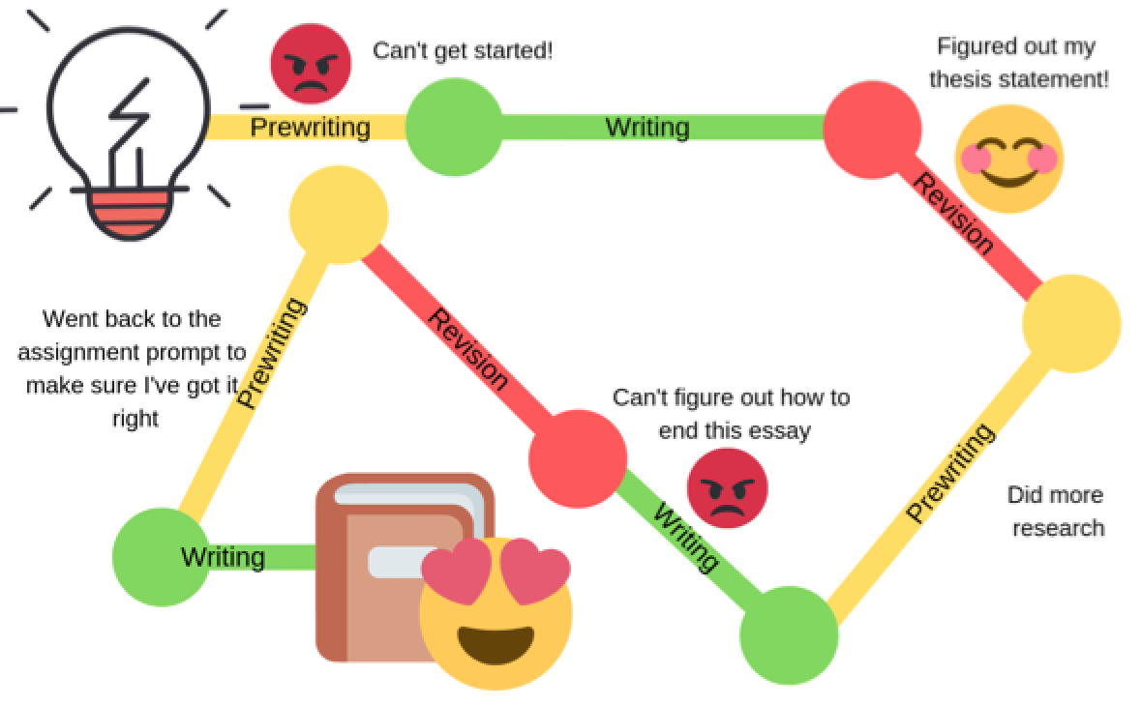
Using the diagram above as a guide, think about the last time that you wrote something important. Now, draw your writing process. Make sure to label major events (such as figuring out your thesis statement) and any strong emotions you felt (pride, frustration, etc).

